Meeting Notice
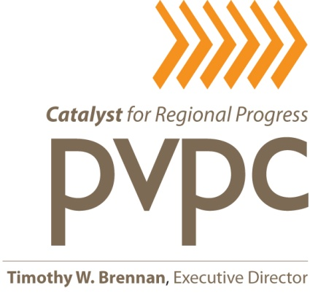
Bike Share Study
Advisory Committee

Wednesday, August 24, 2016
Pioneer Valley Planning Commission
60 Congress Street, Springfield, MA
2nd Floor, Large Conference Room
10:00am

A G E N D A

- Update on Federal Funding and other Funding Status
  - MPO Meeting Outcome on CMAQ Funding
  - Coca Cola Grant Application

- Review and Approval of Scope of Work for CMAQ Funding to MassDOT
- Update on Corporate Sponsorship meetings
  - Sponsorship Brochure, Cover Letter and Targeted Mailing List
  - Peoples Bank
  - Cooley Dickinson Hospital
- Gazette Editorial and Response

- Finalizing Station Locations and Permitting

- Status of Municipal Contributions for PVPC Bike Share Pre-launch Support

- Meetings with Municipal Leaders

- Community Outreach Activities

- Set next meeting date

