Meeting Notice
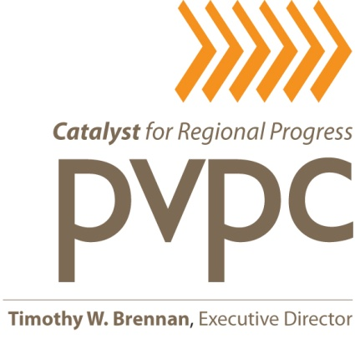
Animal Cross Boarder Control
Task Force Meeting

Tuesday, November 17, 2015
Palmer Town Hall
4417 Main Street, Room 1
Palmer, MA 01069
2:00 p.m.

A G E N D A

- Introduction (5 minutes)

- Update on Regional Agreement (15 minutes)

- Guest Speaker: Lori Swanson, Human Education & Volunteer Services - from Dakin Humane (30 minutes)

- Other Business / Set Next Meeting Date (5 minutes)

Duration - 55 minutes

________________________________________________________________________________________________________________________________________________________________________________________________________________________________________________________________________________________________________________________________________________________________________________________________________________________________________________________________________________________________________________________________________________________________________________________________________________________________________________________________________________________________________________________________________________________________________________________________________________________________

