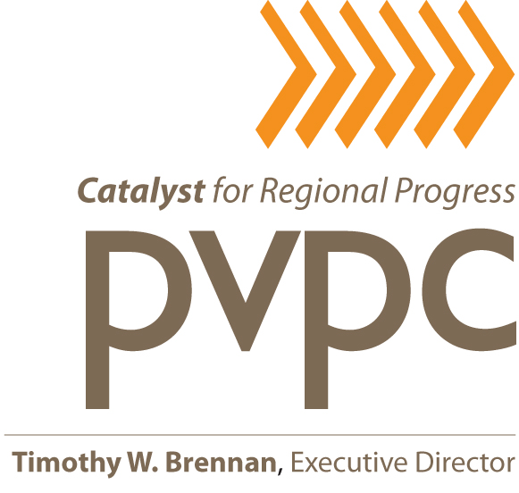

EXECUTIVE COMMITTEE MEETING

DATE: Thursday, January 31, 2019

TIME: 4:00 p.m.

PLACE: Pioneer Valley Planning Commission (PVPC)
60 Congress Street – 2nd Floor, Large Conference Room
Springfield, Massachusetts 01104

A G E N D A

 |  | Action | Information
1. | Chairman’s Call to Order, Welcome and Approval of the Minutes of the Executive Committee Meeting Held on November 29, 2018 (these meeting minutes to be distributed) | ☑
2. | Presentation of the PVPC’s Fiscal Year 2018 Audit Reports as Prepared by the Commission’s CPA Firm Melanson Heath & Company P.C. (copies of the PVPC’s FY2018 Audit Reports and Management Letter are attached)  Special Guest: • Patrice Squillante, CPA, Melanson Heath & Company | ☑ | ☑
3. | Warrant/Financial Reports (to be distributed) |  | ☑
4. | Authorization for the Executive Director to Negotiate and Execute a Mutually Acceptable Contractual Agreement With the Public Health Institute of Western Massachusetts to Conduct Data Collection and Analysis Work Required for a Regional Community Health Needs Assessment | ☑
5. | Authorization for the Executive Director to Negotiate and Execute a Mutually Acceptable Contractual Agreement With the Town of Southampton for the Preparation of a Low Impact Development Approach and Companion Stormwater Design Standards | ☑
6. | Authorization for the Executive Director to Negotiate and Execute a Mutually Acceptable Contractual Agreement With the City of Chicopee to Implement a Stormwater Management and Stream Restoration Project for Enhanced Water Quality in Lower Abbey Brook | ☑
 |  | Action | Information
7. | Authorization for the Executive Director to Negotiate and Execute a Mutually Acceptable Contractual Agreement With the Central Massachusetts Regional Planning Commission (CMRPC) to Provide Housing Rehabilitation Program Management Services | ☑
8. | Authorization for the Executive Director to Negotiate and Execute a Mutually Acceptable Contractual Agreement With William Scanlon for Land Use Planning and Zoning Consultant Services | ☑
9. | Authorization for the Executive Director to Negotiate and Execute a Mutually Acceptable Contractual Agreement With the Behavioral Health Network (BHN), at Valley Human Services, for Domestic Violence Prevention Services | ☑
10. | Authorization for the Executive Director to Negotiate and Execute a Mutually Acceptable Contractual Agreement With the Town of Chester for Green Communities Technical Assistance Services Retroactive to November 1, 2018 | ☑ | ☑
11. | Authorization to Commit an Additional $11,000 of PVPC Local Funds to the Planning Commission’s Special Projects Funding Pool for the Second Half of Fiscal Year 2019 | ☑
12. | Personnel Issues Including Recent Staff Recruitment Efforts; a 12-7-18 Transportation Staff Resignation (see attached staff resignation letter dated 12-3-18); and, an Update on the Recent Activities of the Executive Director Search Committee |  | ☑
13. | Executive Director’s Highlights Including Noteworthy Staff/Agency Accomplishments |  | ☑
14. | Other Business  ADJOURN | ☑ | ☑

TWB/ls
Attachments - 5

cc: PVPC Staff
P. Squillante, Melanson Heath & Company

a-excmte 1.31.19/admin/commission/agendas

