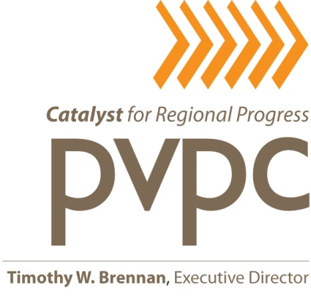

EXECUTIVE COMMITTEE MEETING

DATE: Thursday, March 26, 2015

TIME: 4:00 p.m.

PLACE: Pioneer Valley Planning Commission (PVPC)
60 Congress Street – 2nd Floor, Large Conference Room
Springfield, Massachusetts 01104

A G E N D A

 |  | Action | Information
1. | Chairman’s Call to Order, Welcome and Approval of the Minutes of the Executive Committee Meeting Held on February 26, 2015 (these meeting minutes are attached)
2. | Warrant/Financial Reports (to be distributed) Including the Commission’s CPA Management Letter for Fiscal Year 2014. (see copy of final letter which is attached)
3. | Update on Ongoing Efforts to Resolve Issues and Repayments Emanating From Audit of the EPA Regional Brownfields Revolving Loan Fund Project Managed by the PVPC
4. | Authorization for the Executive Director to Negotiate and Execute a Mutually Acceptable Contractual Agreement With Accountant Eric A. Kinsherf for Municipal Accounting Services to Assist the Towns of Blandford and Chesterfield Under the Provisions of the PVPC’s 2015 District Local Technical Assistance Program (DLTA)
5. | Authorization for the Executive Director to Negotiate and Execute a Mutually Acceptable Contractual Agreement With the Massachusetts Department of Transportation in Order for the PVPC to Perform Transit Planning Work Activities and Tasks in Federal Fiscal Years 2015 and 2016 as Outlined in the Region’s Approved 2015 Unified Planning Work Program and as Funded by the Federal Transit Administration (FTA)
6. | Authorization for the Executive Director to Negotiate and Execute a Mutually Acceptable Contractual Agreement With the Pioneer Valley Transit Authority (PVTA) to Provide the Required 20% Match to the Commission’s Section 5303 FTA Grant Award as Well as to Provide Supplemental Transit Planning and GIS Mapping Work in Federal Fiscal Years 2015 and 2016 as Outlined in the Region’s Approved 2015 Unified Planning Work Program |  | I Action Information
7. | Authorization for the Executive Director to Negotiate and Execute a Mutually Acceptable Contractual Agreement With the Town of Russell to Administer the Outreach Component of the Southern Hilltown Council on Aging Consortium
8. | Authorization for the Executive Director to Negotiate and Execute a Mutually Acceptable Contractual Agreement With the Hilltown Community Health Centers, Inc. to Implement the Outreach Component of the Southern Hilltown Council on Aging Consortium
 |  | Action | Information
9. | Authorization for the Executive Director to Negotiate and Execute a Mutually Acceptable Contractual Agreement With the Town of Russell to Manage its Massachusetts Executive Office of Housing and Economic Development MassWorks Infrastructure Program for the  Carrington Road Retaining Wall Replacement Project.
10. | Review, Discussion and Proposed Adoption of a Series of Recommended Revisions to the PVPC’s Operations Manual in Order to Clarify Language and to Address Identified Gaps (see attached staff memo from Jim Mazik dated 3-11-15)
11. | Personnel Issues Including Updates on Recent Recruitment Efforts, Massachusetts State Retirement Board Issues and Conduct of the Executive Director’s 2014 Annual Performance Evaluation
12. | Executive Director’s Highlights
13. | Other Business  ADJOURN

TWB/ls
Attachments

cc: PVPC Staff

a-excmte3.26.15/admin/commission/agendas

