APPENDIX

APPENDIX A RECOMMENDED PROCEDURAL STEPS BY SUBDIVIDER FOR
SUBMISSION OF SUBDIVISION PLANS FOR APPROVAL 9-2

APPENDIX B: TYPICAL STREET CROSS SECTION, PAVEMENT DETAILS &
INTERSECTION DIAGRAMS 9-3

APPENDIX C: COMPLETE STREETS 9-5

APPENDIX D: HEALTHYCOMMUNITIES 9-9

APPENDIX E: STORMWATER MANAGEMENT REQUIREMENTS 9-13

APPENDIX F: SAMPLE DEVELOPMENT IMPACT STATEMENT 9-21

APPENDIX G: “OUTSIDE CONSULTANTS” FEES (M.G.L. CHPT 44 SEC. 53G) 9-25

APPENDIX H: AUTHORITY OF THE BOARD TO ALLOW EXCEPTIONS AND WAIVE REQUIREMENTS UNDER THE SUBDIVISION CONTROL LAW 9-27

APPENDIX I: SELECTED PROBLEMS IN SUBDIVISION CONTROL 9-29

APPENDIX A
RECOMMENDED PROCEDURAL STEPS BY SUBDIVIDER
FOR SUBMISSION OF SUBDIVISION PLANS FOR APPROVAL (*)

The Subdivider:

1. Discusses subdivision requirements with the Planning Department preferably on the basis of an informal sketch Plan.
2. Prepares a Preliminary Plan and submits it with proper application form to the Planning Board.
3. Submits prints of the plan to the Board of Health, Conservation Commission, Police, Fire and Highways Departments.
4. Files a copy of the application form signed by the Chairman or Clerk of the Planning Board with the [Town/City] Clerk as a notice of plan submission.
5. Attends Planning Board meeting with his Land Surveyor and Engineer for plan review and approval by the Board with representatives of other involved [Town/City] agencies.
6. Prepares a Definitive Plan on the basis of the approved Preliminary Plan and submits it (including a digital pdf copy) to the Planning Board with proper application form and fee.
7. Submits prints of the plan to the Board of Health, Conservation Commission, Police, Fire and Highways Departments.
8. Files a copy of the application form signed by the Chairman or Clerk of the Planning Board with the [Town/City] Clerk as a notice of plan submission.
9. Submits such additional data and information as may be required by the Planning Board and Board of Health.
10. Attends the public hearing held by the Planning Board with his Land Surveyor and Engineer.
11. Puts up a bond or deposit in the amount determined by the Planning Board or signs a covenant after the Definitive Plan has been approved by the Board of Health and by the Planning Board.
12. Files the approved lot plan after it is endorsed by the Planning Board in the Registry and furnishes a paper and electronic (pdf and CAD (DWG)) copy and of the recorded plan to the Planning Board.
13. Proceeds with the construction of road and other required improvements and installation of municipal services in accordance with the approved (and endorsed) plan and recommendations of the Board of Health and in conformance with the established standards and specifications for such improvements in the [Town/City], and subject to periodic inspections by appropriate [Town/City] agencies.
14. Notifies the Planning Board when all required construction and installation of required improvements and services is completed and requests that the bond, deposit or covenant be released.

(*) See the Planning Board’s Subdivision Rules and Regulations for detailed requirements.
APPENDIX B

TYPICAL STREET CROSS SECTION, PAVEMENT DETAILS & INTERSECTION DIAGRAMS

Typical Street Cross Sections
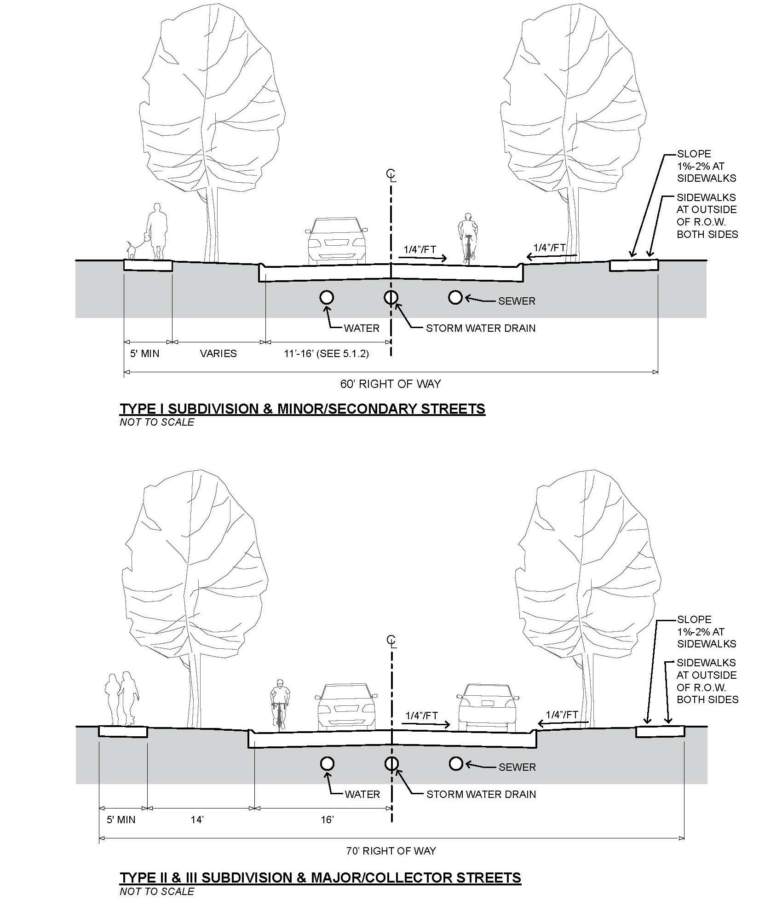

Pavement Details
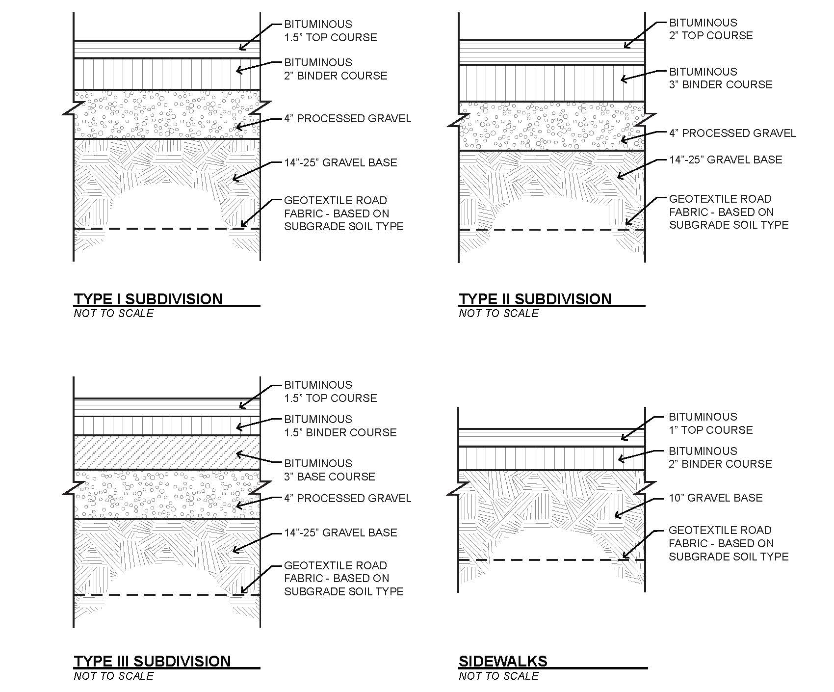

Intersection Diagrams

APPENDIX C
COMPLETE STREETS

MassDOT Complete Streets Program details

The MassDOT Complete Streets Funding Program provides technical assistance and construction funding to eligible municipalities. Eligible municipalities must:
- pass a Complete Streets Policy and
- develop a Prioritization Plan.

All Program news, guidance, and registration information are available through an online Portal https://masscompletestreets.com/

A Complete Street is one that provides safe and accessible options for all travel modes - walking, biking, transit and vehicles – for people of all ages and abilities.

It is key for private developers to follow our community’s Complete Streets vision. To ensure a shared vision, name of municipality __________ will review all proposed developments to determine if they adequately incorporate Complete Streets.

Example Complete Streets Policy:

_____ (Name of Community) Complete Streets Policy

Where feasible, Complete Streets design recommendations shall be incorporated into all publicly and privately funded projects. This includes transportation infrastructure and street design projects requiring funding or approval by the Town of Reading, as well as projects funded by the state and federal government, such as the Chapter 90 funds, Town improvement grants, Transportation Improvement Program (TIP), the MassWorks Infrastructure Program, Community Development Block Grants (CDBG), Capital Funding and other state and federal funds for street and infrastructure design. The same will be applied to private developments and related street design components or corresponding street-related components. In addition, to the extent practical, state-owned roadways will comply with the Complete Streets resolution, including the design, construction, and maintenance of such roadways within Town boundaries. The Town Engineer, in consultation with the Department of Public Works and/or the Parking/ Traffic/ Transportation Task Force as needed, will use best judgment regarding the feasibility of applying Complete Streets principles for routine roadway maintenance and projects.

Most Recent Design Standards

All roadways shall be designed and constructed in compliance with the Community’s Complete Streets policy and related Design Guides. Design considerations may include: bike or bus lanes, road narrowing, sidewalks, crosswalks, and facilities such as covered bus stops or bicycle parking.

If such details are not specified in the policy and if no community-specific design guide exists, then follow the guidelines as detailed below:

Separated Bike Lanes

The applicant shall adhere to the MassDOT separated Bike Land Planning Design Guide available at: https://www.mass.gov/lists/separated-bike-lane-planning-design-guide

For all other Complete Streets improvements

The applicant shall review and consider the design elements contained in the Urban, Rural and Suburban Complete Streets Design Manual prepared by Alta Planning & Design for the city of Northampton and communities in Hampshire County available at: https://www.northamptonma.gov/DocumentCenter/View/6668/Hampshire-County-Complete-Streets-Design-Manual_1-4-2017-FINAL?bidId=

Bike Lane Matrix. Image/text from the Urban, Rural and Suburban Complete Streets Design Manual, created by Healthy Hampshire and the City of Northampton, 2017

Americans with Disabilities Act (ADA) Standards for Accessible Design (28 CFR Part 36), 1994.

A number of federal actions and publications address ADA standards. In 1990, Congress passed the Americans with Disabilities Act21, which is civil rights legislation that prohibits discrimination on the basis of disability. The ADA Standards for Accessible Design 22 furthers the Act through guidelines for accessibility applied during the design, construction, and alteration of both buildings and transportation facilities. In 1999, the U.S. Access Board published Accessible Rights‐of‐ Way: A Design Guide that provides guidance on the design of public rights‐of‐way. Also, FHWA’s Designing Sidewalks and Trails for Access, Parts I and II 24 offers extensive guidance on developing accessible pedestrian rights‐of‐way. Accessibility laws, implementing regulations, and standards require that, where pedestrian facilities are newly provided or altered, they be accessible to and usable by people with disabilities. Furthermore, Title II of the ADA specifically requires the construction of curb ramps along existing pedestrian routes. In addition, if pedestrian use is required through local or other regulations, such as a neighborhood walk‐to‐school requirement or a bus stop along a roadway, accessible facilities should be available.

Best Practices & Policies

- Provide a Variety of Travel Routes. Those walking or biking are more likely to do so when they feel safe and comfortable. Therefore, a variety of routes should be provided so non‐motorized facilities are planned along streets with travel conditions that would naturally attract such activity. This involves providing connections to adjacent neighborhoods, re‐routing bike traffic to secondary roads, or designing roadside facilities that include buffers and other elements to improve comfort levels.
- Provide for Safe Travel Along the Street. A variety of options may be considered to facilitate non‐motorized and transit travel. Depending on the context, bike lanes, cycle tracks, sidewalks and pathways can all assist in moving pedestrian and bicycle traffic
- Provide for Safe Travel Across the Street. Where travel along the street is often considered in non‐motorized planning, it is often the travel across the street that can deter non‐motorized activity.
- Encourage walking and bicycling. In addition to the obvious transportation, energy and environmental benefits of walking and bicycling as an alternative to motorized travel, public health experts are encouraging walking and bicycling as a way of improving health, including a response to the obesity “epidemic.” Literature shows that states with higher levels of bicycling and walking also have a greater percentage of adults who meet the recommended 30‐plus minutes of daily physical activity
- Improve economic health. A balanced transportation system that includes complete streets can bolster economic growth and stability by providing accessible and efficient connections between residences, schools, parks, public transportation, offices, and retail destinations.
- Improve Safety. Attention to travel speed and facilities for all modes can help improve safety. Separated lanes, crosswalks, pedestrian refuge medians, and pedestrian walk signals are all measures that may help improve safety. Depending on the type of measure implemented and speed reductions achieved, traffic calming has reduced collisions by 20 to 70 percent.
- Expand the efficiency of transportation modes. Streets that provide travel choices can increase the overall capacity of the transportation network and move people more efficiently.4 On a project‐by‐project level, a holistic approach to incorporating all modes can reduce the need to retrofit streets at a later date, which saves valuable time and resources.
- Enhance safety for children and the elderly. Complete streets are beneficial for all segments of the population, but particularly for children and the elderly. Youth under age 16 ride bicycles more than any other segment of the population.6 Thus, it is important to provide a safe and well‐connected network for children to get to school by walking and bicycling. Mobility for the elderly is an increasing need, particularly for those without access to a vehicle or for those who feel less safe driving.
- Benefit the environment. Walking, bicycling and taking transit are no or low‐emission options for traveling. Statistics show that by using transit instead of driving to work, a commuter can reduce their carbon‐dioxide emissions by 20 pounds per day, or more than 4,800 pounds per year.

Design Elements

It is key for private developers to follow our community’s Complete Streets vision. To ensure a shared vision, name of municipality __________ will review all proposed developments to determine if they adequately incorporate Complete Streets.

- Requiring sidewalks and shade trees helps create a safe and comfortable pedestrian environment that promotes walking.
- Requiring narrower roads and traffic calming measures creates safer streets for pedestrians and enables children to travel safely and to be more active. This is especially true if a subdivision sets aside land for a playground or community park.
- Connecting sidewalks and bike lanes to larger networks creates additional opportunities for physical activity and allows people to access the larger community without having to rely on an automobile. For example, connections to sidewalk networks can allow children to walk or bike to school.
Subdivision Regulations Checklist

- Require sidewalks.
  - In rural environments or other locations where sidewalks on both sides of the street may not make sense, a sidewalk on one side of the street may be acceptable.
- Require interconnecting street and sidewalk networks.
  - If a dead-end is created, require the subdivision design to allow for streets to be connectable in the future.
  - Where applicable, require multi-use paths at the end of dead-end streets that connect to a larger network of pathways.
  - Require bicycle and pedestrian linkages to nearby public ways.
- Design driveways to minimize pedestrian impacts.
  - Encourage shared/common driveways to reduce the number of automobile curb cuts.
  - Require driveways to rise up to the level of the sidewalk instead of designing the sidewalk to descend to the level of the driveway.
- Narrow road widths and the turning radius at intersections to reduce traffic speeds and the crossing distance at intersections. (Reducing the total amount of pavement also decreases stormwater runoff pollution impacts on waterways as well as urban heat island effects).
- Encourage a preliminary meeting with the Planning Department/departmental review meeting prior to subdivision design to review potential healthy design strategies.
- Encourage submission of Preliminary Subdivision Plans to provide an opportunity to encourage healthy design strategies before plans are finalized.
- Create an Inter-Departmental Project Review Process that establishes meetings of representatives from various municipal departments/boards, including the Board of Health, to provide review and feedback on projects while still in design development.
- Require roads to be designed to “Complete Streets” standards, with equal attention to the needs of automobiles, cyclists and pedestrians.
- Require shade trees along pedestrian and bicycle pathways.
- Require traffic and environmental impact studies for larger subdivisions.
- Require an analysis of pedestrian circulation for subdivisions.

APPENDIX D
HEALTHY COMMUNITIES

A Healthy Community is where people come together to make their community better for themselves, their family, their friends, their neighbors, and others. A Healthy Community creates ongoing dialogue, generates leadership opportunities for all, embraces diversity, connects people and resources, fosters a sense of community, and shapes its future. (MA DPH Office of Healthy Communities – 2013)

Healthy Community design is about planning and designing communities to make it easier for people to live healthy lives. Healthy Community design encourages mixed land uses to bring people closer to the places where they live, work, worship, and play. Doing so reduces dependence on cars and provides affordable housing, good bicycle and pedestrian infrastructure, space for social gathering, and access to transit, parks, and healthy foods. (US CDC – 2013)

In 2014, the Massachusetts Department of Public Health (MA DPH) engaged the Pioneer Valley Planning Commission (PVPC) to develop a Healthy Community Design Toolkit for the Commonwealth of Massachusetts. This toolkit is available at: https://www.mass.gov/files/documents/2016/07/vr/healthy-comm-design-toolkit.pdf

Developers wishing to make their projects as healthy as possible are encouraged to use the MA Healthy Community Design Toolkit. The toolkit includes a Subdivision Regulations Checklist:

    - Require sidewalks.
    - In rural environments or other locations where sidewalks on both sides of the street may not make sense, a sidewalk on one side of the street may be acceptable.
    - Require interconnecting street and sidewalk networks.
  - If a dead-end is created, require the subdivision design to allow for streets to be connectable in the future.
  - Where applicable, require multi-use paths at the end of dead-end streets that connect to a larger network of pathways.
  - Require bicycle and pedestrian linkages to nearby public ways.
    - Design driveways to minimize pedestrian impacts.
  - Encourage shared/common driveways to reduce the number of automobile curb cuts.
  - Require driveways to rise up to the level of the sidewalk instead of designing the sidewalk to descend to the level of the driveway.
    - Narrow road widths and the turning radius at intersections to reduce traffic speeds and the crossing distance at intersections. (Reducing the total amount of pavement also decreases stormwater runoff pollution impacts on waterways as well as urban heat island effects).
    - Encourage a preliminary meeting with the Planning Board/Department prior to subdivision design to review potential healthy design strategies.
    - Encourage submission of Preliminary Subdivision Plans to provide an opportunity to encourage healthy design strategies before plans are finalized.
    - Create an Inter-Departmental Project Review Process that establishes meetings of representatives from various municipal departments/boards, including the Board of Health, to provide review and feedback on projects while still in design development.

    - Require a set-aside of future parkland (even if only temporary, as required by Massachusetts law), to give the homeowner’s association, municipality or other entity time to acquire it.
    - Require roads to be designed to “Complete Streets” standards, with equal attention to the needs of automobiles, cyclists and pedestrians.
    - Require shade trees along pedestrian and bicycle pathways.
    - Require traffic and environmental impact studies for larger subdivisions.
    - Require an analysis of pedestrian circulation for subdivisions.

Most Recent Design Standards/Best Practices & Policies/Design Elements

For municipalities that have Design Guidelines related to Healthy Community design [please insert reference to them here].

In addition to the Massachusetts Healthy Community Design Toolkit, these resources may be helpful.

New York City (New York), City of, Center for Active Design. 2010. Active Design Guidelines: Promoting Physical Activity and Health in Design. https://centerforactivedesign.org/dl/guidelines.pdf

- This seminal document provides guidelines that promote active, healthy living in urban design (land use mix, transit and parking, parks/open space/recreational facilities, children's play areas, public plazas, grocery stores/fresh produce access, street connectivity, traffic calming, pedestrian pathways, streetscape programming, and bicycle networks/infrastructure) and building design (stairway use, and building programming, facilities, and exteriors/massing that support physical activity).

Peel (Ontario), Region of. 2014. Affordable Housing Active Design Guidelines and Standards.
http://www.peelregion.ca/health/resources/healthbydesign/pdf/CDI-0560.pdf

- Provides a set of elements for consideration during the procurement, design, and rehabilitation or retrofit phases of affordable housing development that promote an active lifestyle among residents.

Toronto Public Health, City of Toronto Planning, City of Toronto Transportation Services and Gladki Planning Associates. 2014. Active City: Designing for Health.
https://www.toronto.ca/legdocs/mmis/2014/hl/bgrd/backgroundfile-69334.pdf

- Report identifies and describes ten "Active City" design principles that address proximity, connectivity, design quality, and equity.

American Planning Association, Planning and Community Health Center. 2015. Health in the Development Review Process. Washington, D.C.: American Planning Association.
https://planning-org-uploaded-media.s3.amazonaws.com/legacy_resources/nationalcenters/health/
toolsforhealth/pdf/devreviewguidelines.pdf

- Guide discusses how local development codes can incorporate healthy community considerations into regulatory language. Identifies the principles of a healthy built environment and applicable code provisions for implementation; offers a health-focused development review checklist.

Los Angeles (California), City of, and Gensler. 2013. Designing a Healthy LA.
http://www.urbandesignla.com/resources/docs/DesigningAHealthyLA/hi/DesigningAHealthyLA.pdf

- This guidebook, intended for those who plan, design, and build the city's buildings, streets, neighborhoods, and open spaces, offers a broad range of guidelines for integrating health into the physical environment.

This page is intentionally left blank

APPENDIX E
STORMWATER MANAGEMENT REQUIREMENTS

1.0 STORMWATER MANAGEMENT PLAN

Choose one of the options below.

For MS4 Permitted Communities:

1.1 An Application for a Stormwater Management Permit, in accordance with [Bylaw/Ordinance], along with all required plans and supportive information and documentation, must be submitted as part of the Definitive Subdivision Plan submission approval.
No work shall commence on the construction of an approved Definitive Subdivision Plan until a Stormwater Management Permit has been approved and issued. Wherever possible the proposed drainage system shall be designed to utilize, and be compatible with, the existing drainage patterns and existing natural features of the site.
The stormwater management plan shall be designed to incorporate and address the stormwater management for the entire proposed development, including anticipated buildout of individual lots.

  - Inspections

1.2.1 In addition to the inspections described in Section 7 of these Subdivision Rules and Regulations, the storm drainage systems shall be inspected at intervals in accordance with the Section __ of the Stormwater Management [Bylaw/Ordinance] of the [Town/City] of _______.

1.2.2 The Stormwater Authority or its agent will join the Project Design Engineer for inspections. The Stormwater Authority or its agent may inspect the work and either approve it or notify the applicant in writing in what respects there has been a failure to comply with the requirements of the approved plan.
Any portion of the work that does not comply shall be promptly corrected by the applicant or the applicant will be subject to the bonding provisions of Section ______ or the penalty provisions of Section ______. The [Town/City] may conduct random inspections to ensure effective control of erosion and sedimentation during all phases of construction.

OR

For Non-MS4 Permitted Communities

1.1 Stormwater Management Plan Required. A Stormwater Management Plan must be submitted as part of the Definitive Subdivision Plan submission approval.

  - Contents of the Stormwater Management Plan. A stormwater management plan submitted with the Definitive Subdivision Plan application shall contain sufficient information for the Stormwater Authority to evaluate the environmental impact, effectiveness and acceptability of measures proposed for reducing adverse impacts from construction stormwater runoff and post-development stormwater runoff.
The stormwater plan shall comply with the criteria established in the [Ordinance/Bylaw] and must be submitted with the stamp and signature of a professional engineer (PE) licensed by the Commonwealth of Massachusetts.
The Stormwater Management Plan shall fully describe the project in narrative, drawings, and calculations, and shall include:
    - Contact information, including the name, address, and telephone number of all persons having a legal interest in the property and the tax reference number and parcel number of the property or properties affected;
    - A locus map;
    - The existing zoning and land use at the site;
    - The proposed land use and proposed area of disturbance;
    - The location(s) of existing and proposed easements;
    - The location of existing and proposed utilities;
    - The site's existing and proposed topography with contours at two-foot intervals;
    - Description of existing site hydrology;
    - Habitats mapped by the Massachusetts Natural Heritage & Endangered Species Program as Endangered, Threatened or of Special Concern, Estimated Habitats of Rare Wildlife and Certified Vernal Pools, and Priority Habitats of Rare Species within five hundred (500) feet of any construction activity;
    - A description and location of existing stormwater conveyances, impoundments, and wetlands on or adjacent to the site or into which storm water flows;
    - A delineation of 100-year flood plains, if applicable;
    - Estimated seasonal high groundwater elevation (November to April) in areas to be used for stormwater retention, detention, or infiltration;
    - The existing and proposed vegetation and ground surfaces with runoff coefficient for each;
    - A drainage area map showing pre and post-construction watershed boundaries, drainage area and storm water flow paths;
    - A description and drawings of all components of the proposed drainage system including:
      - Locations, cross sections, and profiles of all brooks, streams, drainage swales and their method of stabilization;
      - All measures for the detention, retention or infiltration of water performed per the requirements of the Massachusetts Stormwater Handbook;
      - All measures for the protection of water quality;
      - The structural details for all components of the proposed drainage systems and storm water management facilities;
      - Notes on drawings specifying materials to be used, construction specifications and details;
      - Expected hydrology with supporting calculations;
      - Proposed improvements including location of buildings or other structures, impervious surfaces, and drainage facilities, if applicable;
      - Environmentally sensitive site design analysis demonstrating, where feasible:
        - reduced impervious surface coverage through street design, street width, parking design, and sidewalks;
        - retention of open space and mature trees;
        - increased development density in exchange for open space protection in other areas of the site.
        - incorporation of decentralized, stormwater management systems to treat and infiltrate stormwater closer to the source.

    - For projects involving redevelopment, “Maximum Extent Practicable” in the Massachusetts Stormwater Management Standards shall be determined by an alternatives analysis that shall include the following:
      - An estimate of peak runoff flows and total runoff volumes from the project site in its undeveloped condition (e.g. no artificial impervious cover) for storm events with 2, 10, 25, and 100-year recurrence intervals.
      - An estimate of peak runoff flows and total runoff volumes from the project site in its existing condition for storm events with 2, 10, 25, and 100-year recurrence intervals.
      - An estimate of peak runoff flows and total runoff volumes from the project site in its redeveloped condition for storm events with 2, 10, 25, and 100-year recurrence intervals.
      - An estimate of the groundwater recharge volume that would be required for infiltration if the project included development of a previously-undeveloped site based on the soil types present, using the infiltration depths for each soil type specified by the Massachusetts Stormwater Handbook
      - A completed Checklist for Redevelopment Projects from the Massachusetts Stormwater Handbook, including an estimate of the proposed percent TSS removal performance and groundwater recharge volume that will be achieved by the proposed redevelopment project.

    - Erosion and Sedimentation Control Plan (ESCP) for Construction Activities:
      - A description of construction and waste materials expected to be stored on site, and a description of controls to reduce pollutants from these materials including storage practices to minimize exposure of the materials to stormwater, and spill prevention and response;
      - Narrative describing all erosion and sediment control practices, including tree preservation and protection;
      - Erosion and sedimentation control plan drawings, including detailed drawings and specifications with sizing calculations;
      - Timing, schedules, and sequence of development including clearing, stripping, rough grading, construction, final grading, and vegetative stabilization;
      - An inspection and maintenance schedule, including an inspection and maintenance log form, for the period of construction (See Section ___ for required construction inspections);

    - Operations, Maintenance, and Inspection Plan that shall serve as the basis for the final agreement as described in Section _____.
      - Names of owners. The name(s) of the owner(s) for all components of the stormwater management system.
      - Maintenance agreements. Maintenance agreements that specify:
        - The names and addresses of the person(s) responsible for operation and maintenance;
        - The person(s) responsible for financing maintenance and emergency repairs;
        - The estimated operations and maintenance budget;
        - A maintenance schedule for all drainage structures, including swales and ponds, and including routine and non-routine maintenance tasks to be performed;
        - A map and list of easements with the purpose and location of each;
        - A plan drawn to scale showing the location of all stormwater BMPS in each treatment train, including catch basins, manholes/access lids, main, and stormwater devices, along with the discharge point;
        - A description and delineation of public safety features;
        - An operation and maintenance log form;
        - Agreement that the person(s) responsible for operation and maintenance will follow this schedule and maintain an operation and maintenance log to include inspections, repairs, replacement and disposal (type of material and disposal location), and will submit annual letter to the Stormwater Authority with such logs attached to document that work has been done over the last 12 months to properly operate and maintain the stormwater control measures;
        - Information on how future property owners will be notified of the presence of the stormwater management system and the requirement for proper operation and maintenance;
        - Provide that, if after notice by the Stormwater Authority or designated agent to correct a violation requiring maintenance work, satisfactory corrections are not made by the owner(s) within 30 days, the Department of Public Works or another agent of the Stormwater Authority, may perform all necessary work to place the facility in proper working condition. The owner(s) of the facility shall be assessed the cost of the work and any penalties.
        - The signature(s) of the owner(s).
      - Stormwater management easements as necessary for:
        - Access for facility inspections and maintenance.
        - Preservation of stormwater runoff conveyance, infiltration, and detention areas and facilities, including flood routes for the 100-year storm event.
        - Direct maintenance access by heavy equipment to structures requiring regular cleanout.

      - Stormwater management easement requirements.
        - Purpose of each easement shall be specified in the maintenance agreement signed by the property owner.
        - Stormwater management easements are required for all areas used for off-site stormwater control, unless a waiver is granted by the Town.
        - Easements shall be recorded with the registry of deeds prior to issuance of a certificate of completion.
      - Changes to operation and maintenance plans.
        - The owner(s) of the stormwater management system must notify the Stormwater Authority of changes in ownership or assignment of financial responsibility.
        - The maintenance schedule in the maintenance agreement may be amended to achieve the purposes of this Bylaw by mutual agreement of the Stormwater Authority and the responsible parties. Amendments must be in writing and signed by all responsible parties. Responsible parties must include owner(s), persons with financial responsibility, and persons with operational responsibility.
      - Maintenance responsibility.
        - The owner of the property on which work has been done pursuant to this Bylaw for private stormwater management facilities, or any other person or agent in control of such property, shall maintain in good condition and promptly repair and restore all grade surfaces, walls, drains, dams and structures, vegetation, erosion and sediment control measures and other protective devices. Such repairs or restoration and maintenance shall be in accordance with approved plans.
        - A maintenance schedule shall be developed for the life of any stormwater management facility and shall state the maintenance to be completed, the time period for completion, and who shall be legally responsible to perform the maintenance. This maintenance schedule shall be printed on the stormwater management plan.
        - Records of installation and maintenance.
        - Failure to maintain practices.
    - Any other information requested by the permitting authority.

2.0 DESIGN STANDARDS

For MS4 Communities:

  - All Stormwater Management Plans must conform to the design standards as enumerated in Section __ of the Stormwater Management [Bylaw/Ordinance] of the [City/Town] of _______.

  - To the fullest extent reasonable and practicable, all subdivisions shall be designed and constructed in conformance with the following documents, as existing or amended:
    - The Massachusetts Erosion and Sediment Control Guidelines for Urban and Suburban Areas (MassDEP)

    - The Massachusetts Stormwater Handbook (MassDEP)

For Non MS4 Communities, consider adding the following standards:

  - Massachusetts Stormwater Handbook Standards. Projects must meet the Massachusetts Stormwater Management Standards. When the proposed discharge may have an impact upon a sensitive receptor, including streams, wetlands, vernal pools, storm sewers, an increase in these minimum requirements, based on existing stormwater system capacity, may be required.

  - Projects must use environmentally sensitive site design, site planning and design strategies to the maximum extent practicable in order to reduce runoff from projects. If full compliance is not provided, an applicant must document why key steps in the process could not be met and what is proposed for mitigation. Strategies should include:
    - Identify, map, and preserve the site's natural features and environmentally sensitive areas such as wetlands, native vegetation, mature trees, slopes, drainage ways, permeable soils, flood plains, woodlands and soils to the greatest extent possible;
    - Minimize grading and clearing;
    - Delineate potential building envelopes, avoiding environmental resource areas and appropriate buffers by clustering buildings and reducing building footprints;
    - Develop methods to minimize impervious surfaces, and protect and preserve open space.
    - Promote erosion and sediment control by using measures that are appropriate to the conditions of the site.

During planning:

- avoid sensitive areas, steep slopes, and highly erodible soils to the maximum extent possible when developing site plans
- identify potential problem areas before the site plan is finalized and approved
- plan to use sediment barriers along contour lines, with a focus on areas where short-circuiting (i.e., flow around the barrier) may occur
- use berms at the top of a steep slopes to divert runoff away from the slope’s edge
- design trapezoidal or parabolic vegetated drainage channels, not triangular
- use vegetated channels with rip rap check dams, instead of impervious pavement or concrete, to reduce the water velocity of the conveyance system.
- design a check dam or sediment forebay with level spreader at the exit of outfalls to reduce water velocity of the discharge and collect sediment.
- use turf reinforcement matting to stabilize vegetated channels, encourage vegetation establishment, and withstand flow velocities without scouring the base of the channel.
- plan open channels to follow land contours so natural drainage is not disrupted.
- use organic matting for temporary slope stabilization and synthetic matting for permanent stabilization.
- provide a stable channel, flume, or slope drain where it is necessary to carry water down slopes.

During construction:

- minimize the amount of disturbed area and protect natural resources
- stabilize sites when projects are complete or operations have temporarily ceased protect all storm drain inlets and armor all newly constructed outlets
- protect slopes on the construction site
- protect all storm drain inlets and armor all newly constructed outlets use perimeter controls that provide protection along the site's edge before sediment reaches roadway, storm drains, or adjacent properties
- stabilize construction site entrances and exits to prevent off-site tracking
- inspect stormwater controls at regular intervals and especially following any storm.

For further guidance, see: Massachusetts Erosion and Sediment Control Guidelines for Urban and Suburban Areas, MassDEP, 2003, as updated.

    - Manage runoff using smaller, decentralized, low-tech stormwater management techniques to treat and recharge stormwater close to the source;
    - Lengthen flow paths and maximize sheet flow;
    - Use native plant vegetation in buffer strips and in rain gardens (small planted depressions that can trap and filter runoff);
    - Use drought-resistant vegetation;
    - Integrate techniques into the site design to create a hydrologically functional lots or development site.
    - Manage all construction materials and wastes on site so as to avoid polluted flows. This includes: demolition materials, excess or discarded building or site material, including but not limited to concrete truck washout, chemicals, litter and sanitary waste. These wastes may not be discharged into any storm drain system owned by the [Town/City] of __________.

This page intentionally left blank

APPENDIX F
SAMPLE DEVELOPMENT IMPACT STATEMENT

A Development Impact Statement (DIS) is a documented, written analysis of a proposed development which provides the Planning Board and Town Officials with information necessary for plan review.

It is a developer’s responsibility to prepare and document the DIS in sufficient detail to permit an adequate evaluation by the Planning Board; however, additional data may be requested in writing by the Board. It is necessary to respond to all sections of the DIS form except when a written exemption is granted by the Planning Board. The applicant is urged to contact the Office of the Town Planner in the process of completing a Development Impact Statement.

NAME OF PROJECT: ACREAGE:

TYPE OF PROJECT: OWNER(S):

LOCATION: PLANNER:

PARCEL NUMBER(S): ENGINEER:

ZONING DISTRICT(S): ARCHITECT:

A. PROJECT DESCRIPTION

1. Number of Units:
Low- Single-
Total ____ Income ____ Family ____

2. Two- Row-
Family ____ House ____ Apt. ____ Other ____

3. Condominium
Ownership ____ Rental ____ Private ____

4. Number of Bedrooms: Row Houses ____ Apartments ____

5. Approximate Price/Unit: Private __________
Condominiums __________
Rental __________

B. CIRCULATION SYSTEMS

1. Street Design – Explain reasons for location of streets, stubs, and intersections. Project the number of motor vehicles to enter or depart the site per average day and peak hour.

2. Parking & Bus Stops – Discuss the number, opportunities for multiple use, and screening of parking spaces. With respect to bus stops, if any, explain the location, shelter design and orientation to any path systems.

C. SUPPORT SYSTEMS

1. Water Distribution

a. Public – Discuss the project’s water distribution system, including projected demand, ability to serve all lots, use of water for air conditioning, and any special problems such as check valves or booster pumps which must be dealt with.
b. Private – Discuss the type of system, level of treatment, suitability of soils and results of percolation tests.

2. Sewage Disposal

a. Public – Discuss the project’s sewage disposal system, including projected flow, size of pumping stations including auxiliary power, and any special problems such as check valves, etc. which must be dealt with, and the effects on the waste water treatment facility.
b. Private – Discuss the type of system, level of treatment, suitability of soils and results of percolation tests.

3. Storm Drainage – Discuss the storm drainage system including the projected flow from 10 year and a 100 year storm, name of the receptor stream, and any flow constriction between the site and the receptor stream.

4. Refuse Disposal – Discuss the location and type of facilities, hazardous materials requiring special precautions, and screening.

5. Lighting – Discuss the location and size of lights, and methods used to screen adjoining properties from glare.

6. Fire Protection – Discuss the type and capacity of fuel storage facilities, location of storage areas for hazardous substances, special requirements, and distance to fire station.

7. Recreation

a. Public – Indicate the distance to and type of public facilities.
b. Private – Discuss the type of private recreation facilities to be provided within the development.

8. Schools – Project the student population of the project for the nursery, elementary, middle school and senior high school levels and indicate the distance, capacity, and present enrollment of the nearest elementary and secondary schools.

D. NATURAL CONDITIONS – Describe briefly the following natural conditions:

1. Topography – Indicate datum, source, date, slopes greater than 25%

2. Soils – Indicate prime agricultural land, depth to bedrock, extent of land
which has been filled.

3. Mineral Resources – Indicate extent and economic importance of resource, extent and means of proposed extraction, rehabilitation measures.

4. Surficial geology

5. Depth to water table

6. Aquifer recharge areas

7. Wetlands

8. Watercourses

9. Flood prone areas

10. Vegetative cover

11. Unique wildlife habitats

12. Unique flora

13. Environmental constraints

E. DESIGN FACTORS – Describe briefly the following features. Photographs are helpful.

1. Present visual quality of the area

2. Location of significant viewpoints

3. Historic structures

4. Architecturally significant structures

5. Type of architecture for development

F. ENVIRONMENTAL IMPACT - Describe briefly the following features.

1. Measures taken to prevent surface water contamination

2. Measures taken to prevent ground water contamination

3. Measures taken to maximize ground water recharge

4. Measures taken to prevent air pollution

5. Measures taken to prevent erosion and sedimentation

6. Measures taken to maintain slope stability

7. Measures taken to reduce noise levels

8. Measures taken to preserve significant views

9. Measures taken to project design to conserve energy

10. Measures taken to preserve wildlife habitats

11. Measures taken to ensure compatibility with surrounding land uses

G. PLANS – Describe briefly how your project is consistent/inconsistent with the
following:

1. Master Plan

2. Open Space Plan

3. Regional plans prepared by the Lower Pioneer Valley Regional Planning Commission

H. PHASING – If the development of the site will take place over more than one year, supply a schedule showing how the development will be phased. A flow chart is helpful. This time table shall include the following elements:

1. Stripping and/or clearing of site

2. Rough grading and construction

3. Construction of grade stabilization and sedimentation control structures

4. Final grading and vegetative establishment

5. Landscaping

6. The construction of any public improvement shall be specified explaining how these improvements are to be integrated with the development.

7. The number of housing units and the square footage of nonresidential uses to be constructed each year and their estimated value shall be specified.

APPENDIX G
“OUTSIDE CONSULTANTS” FEES

M.G.L. Chapter 44: Section 53G - Employment of Outside Consultants
(abbreviated version)

Who:
- Section 8C of chapter 40 (Conservation Commissions)
- Section 9 or 12 of chapter 40A (Zoning Special Permit Granting Authorities & ZBA’s)
- Section 21 of chapter 40B (ZBA/Comprehensive Permits)
- Section 81Q of chapter 41 (Planning Boards, Subdivision control Law)
- Section 31 of chapter 111 (Boards of Health)

For:
- the imposition of reasonable fees for the employment of outside consultants

Fees:
- deposit in a special account established by the municipal treasurer in the municipal treasury
- kept separate and apart from other monies
- shall be expended (including interest, if any) at the direction of the authorized board or authority without further appropriation
- expended only in connection with carrying out its responsibilities under the law
- at completion of project any excess amount in the account (including accrued interest) attributable to a specific project, shall be repaid to the applicant/successor in interest
- a final report of said account shall be made available to the applicant/successor in interest
- municipal accountant shall submit annually a report of said special account to the chief elected body and chief administrative official of the municipality for their review
- said report shall be published in the city or town annual report
- municipal accountant shall submit annually a copy of said report to the director of the bureau of accounts.

Administrative Appeal:
- rules shall provide for an appeal from the selection of the outside consultant to the board of selectmen
- grounds for an appeal shall be limited to claims that:
- the consultant selected has a conflict of interest or
- does not possess the minimum, required qualifications
- minimum qualifications shall consist either of an educational degree in or related to the field at issue, or three or more years of practice in the field at issue or a related field
- required time limits for action upon an application by the permit granting board shall be extended by the duration of the administrative appeal

- if no decision is made by the board of selectmen within one month following the filing of the appeal, the selection made by the permit granting authority shall stand
- such an administrative appeal shall not preclude further judicial review, if otherwise permitted by law, on the grounds provided for in this section.

Full Text:

M.G.L. CHAPTER 44. MUNICIPAL FINANCE

Section 53G. Employment of Outside Consultants

Notwithstanding section 53, any city or town that provides by rules promulgated under section 9 or 12 of chapter 40A, section 21 of chapter 40B, section 81Q of chapter 41 or section 31 of chapter 111, or by rules promulgated by a conservation commission established by a city or town under section 8C of chapter 40 when implementing the authority conferred under said section 8C of said chapter 40, section 40 of chapter 131, or under any local wetlands ordinance or by-law, for the imposition of reasonable fees for the employment of outside consultants may deposit such fees in a special account. Such rules shall provide for an administrative appeal from the selection of the outside consultant to the city council or town board of selectmen. The grounds for such an appeal shall be limited to claims that the consultant selected has a conflict of interest or does not possess the minimum, required qualifications. The minimum qualifications shall consist either of an educational degree in or related to the field at issue or three or more years of practice in the field at issue or a related field. The required time limits for action upon an application by a municipal permit granting board shall be extended by the duration of the administrative appeal. In the event that no decision is made by the city council or the town board of selectmen within one month following the filing of the appeal, the selection made by the municipal permit granting authority shall stand. Such an administrative appeal shall not preclude further judicial review, if otherwise permitted by law, on the grounds provided for in this section. Any such account shall be established by the municipal treasurer in the municipal treasury and shall be kept separate and apart from other monies. The special account, including accrued interest, if any, shall be expended at the direction of the authorized board or authority without further appropriation; provided, however, that such funds are to be expended by it only in connection with carrying out its responsibilities under the law. Any excess amount in the account attributable to a specific project, including any accrued interest, at the completion of said project shall be repaid to the applicant or to the applicant’s successor in interest and a final report of said account shall be made available to the applicant or to the applicant’s successor in interest. The municipal accountant shall submit annually a report of said special account to the chief elected body and chief administrative official of the municipality for their review. Said report shall be published in the city or town annual report. The municipal accountant shall submit annually a copy of said report to the director of the bureau of accounts.

APPENDIX H
AUTHORITY OF THE PLANNING BOARD TO ALLOW EXCEPTIONS AND WAIVE REQUIREMENTS UNDER THE SUBDIVISION CONTROL LAW

Requirements Which Can Be Waived:

The authority given to the Planning Board to make exceptions and waive compliance with the Subdivision Rules and Regulations is found in Sections 81-M and 81-R.

Section 81-M states, in part, as follows: "... such board (Planning Board) may, when appropriate, waive, as provided for in section eighty-one R, such portions of the rules and regulations as is deemed advisable." It is up to the applicant to provide the Planning Board with sufficient information to justify a waiver and convince the Planning Board of its appropriateness.

Section 81-R authorizes the Planning Board, "... in any particular case where such action is in the public interest and not inconsistent with the intent and purpose of the Subdivision Control Law, ..." to waive requirements regarding the following:

A. Strict compliance with the Subdivision Rules and Regulations may be waived. Such waivers are commonly confined to specific land development standards such as road construction details, in accordance with the provisions of Section 81-Q which states, in part, as follows: "In establishing such requirement regarding ways, due regard shall be paid (by the Planning Board) to the prospective character of different subdivision, ... and the prospective amount of travel upon the various ways therein, and to adjustment of the requirements accordingly."

B. The Planning Board may, "... where roads are not otherwise deemed adequate, approve a plan on conditions limiting the lots upon which buildings may be erected and the number of buildings that may be erected on particular lots and the length of time for which particular buildings may be maintained without further consent by the Planning Board to the access provided. The Planning Board shall endorse such conditions on the plan to which they relate, or set them forth in a separate instrument attached thereto, to which reference is made on such plan and which shall for the purpose of the Subdivision Control Law be deemed to be a part of the plan."

C. Frontage or access requirements specified in the Subdivision Control Law may be waived. (Cannot be waived, if required by Zoning [Bylaw/Ordinance])

NOTE: A specific requirement as to lot frontage in a subdivision is found in Section 81-O which states, in part, as follows: provided every lot "... has frontage on a public way or way shown on a plan approved in accordance with the Subdivision Control Law of least such distance, if any, as is then required by Ordinance or Bylaw/ordinance of said city or [Town/City] for erection of a building on such lot, and if no distance is so required has such frontage of at least twenty feet."

Requirements Which Cannot Be Waived:

With the above exceptions, all other statutory requirements contained in the Subdivision Control Law though frequently included in the Planning Board's Subdivision Rules and Regulations cannot be waived or modified but must be carefully followed. Among such requirement the following are found to be included:

A. Requirements governing the submission, amendment, approval, endorsement and recording of definitive plans prepared by registered land surveyors.

B. Approval of plans by the Board of Health.

C. Requirements regarding performance guarantees for completion of the work in accordance with the Subdivision Rules and Regulations, and the recommendations of the Board of Health before the plan is endorsed by the Planning Board.

D. Procedure and requirements regarding the adoption, amendment and filing of the Subdivision Rules and Regulations by the Planning Board.

Summary

Although a rather broad authority has been delegated to the Planning Board, to waive the various requirements under the Subdivision Control Law, it is in the public interest to bear always in mind the purposes of the Subdivision Control as set forth in Section 81-M. Among those the most basic requirement is the provision of adequate access to all of the lots in a subdivision by ways that will be safe and convenient for travel.

APPENDIX I
SELECTED PROBLEMS IN SUBDIVISION CONTROL

Problem 1 – Frontage

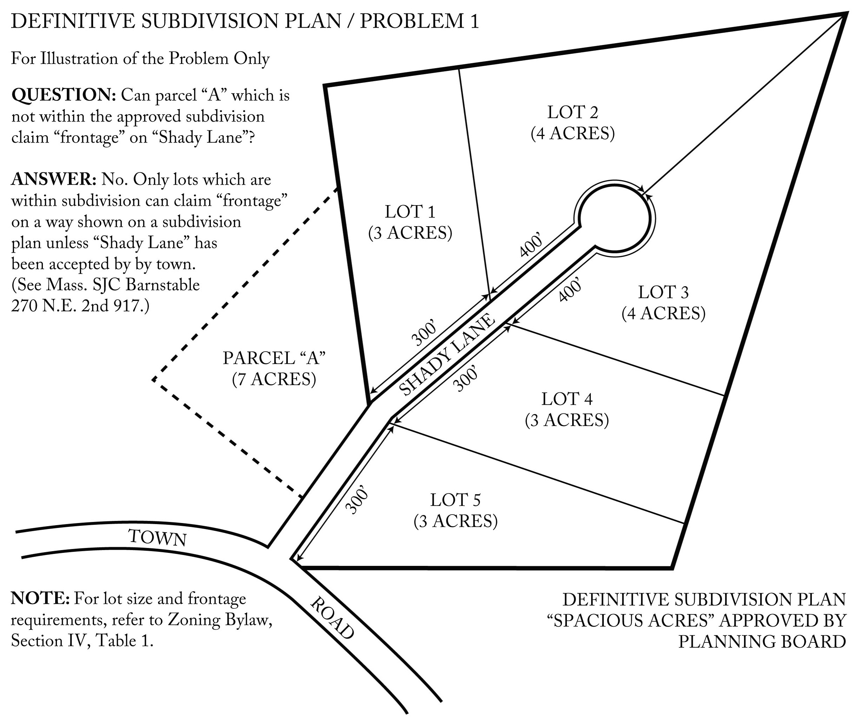

Problem 2 - Revision to Road Layout

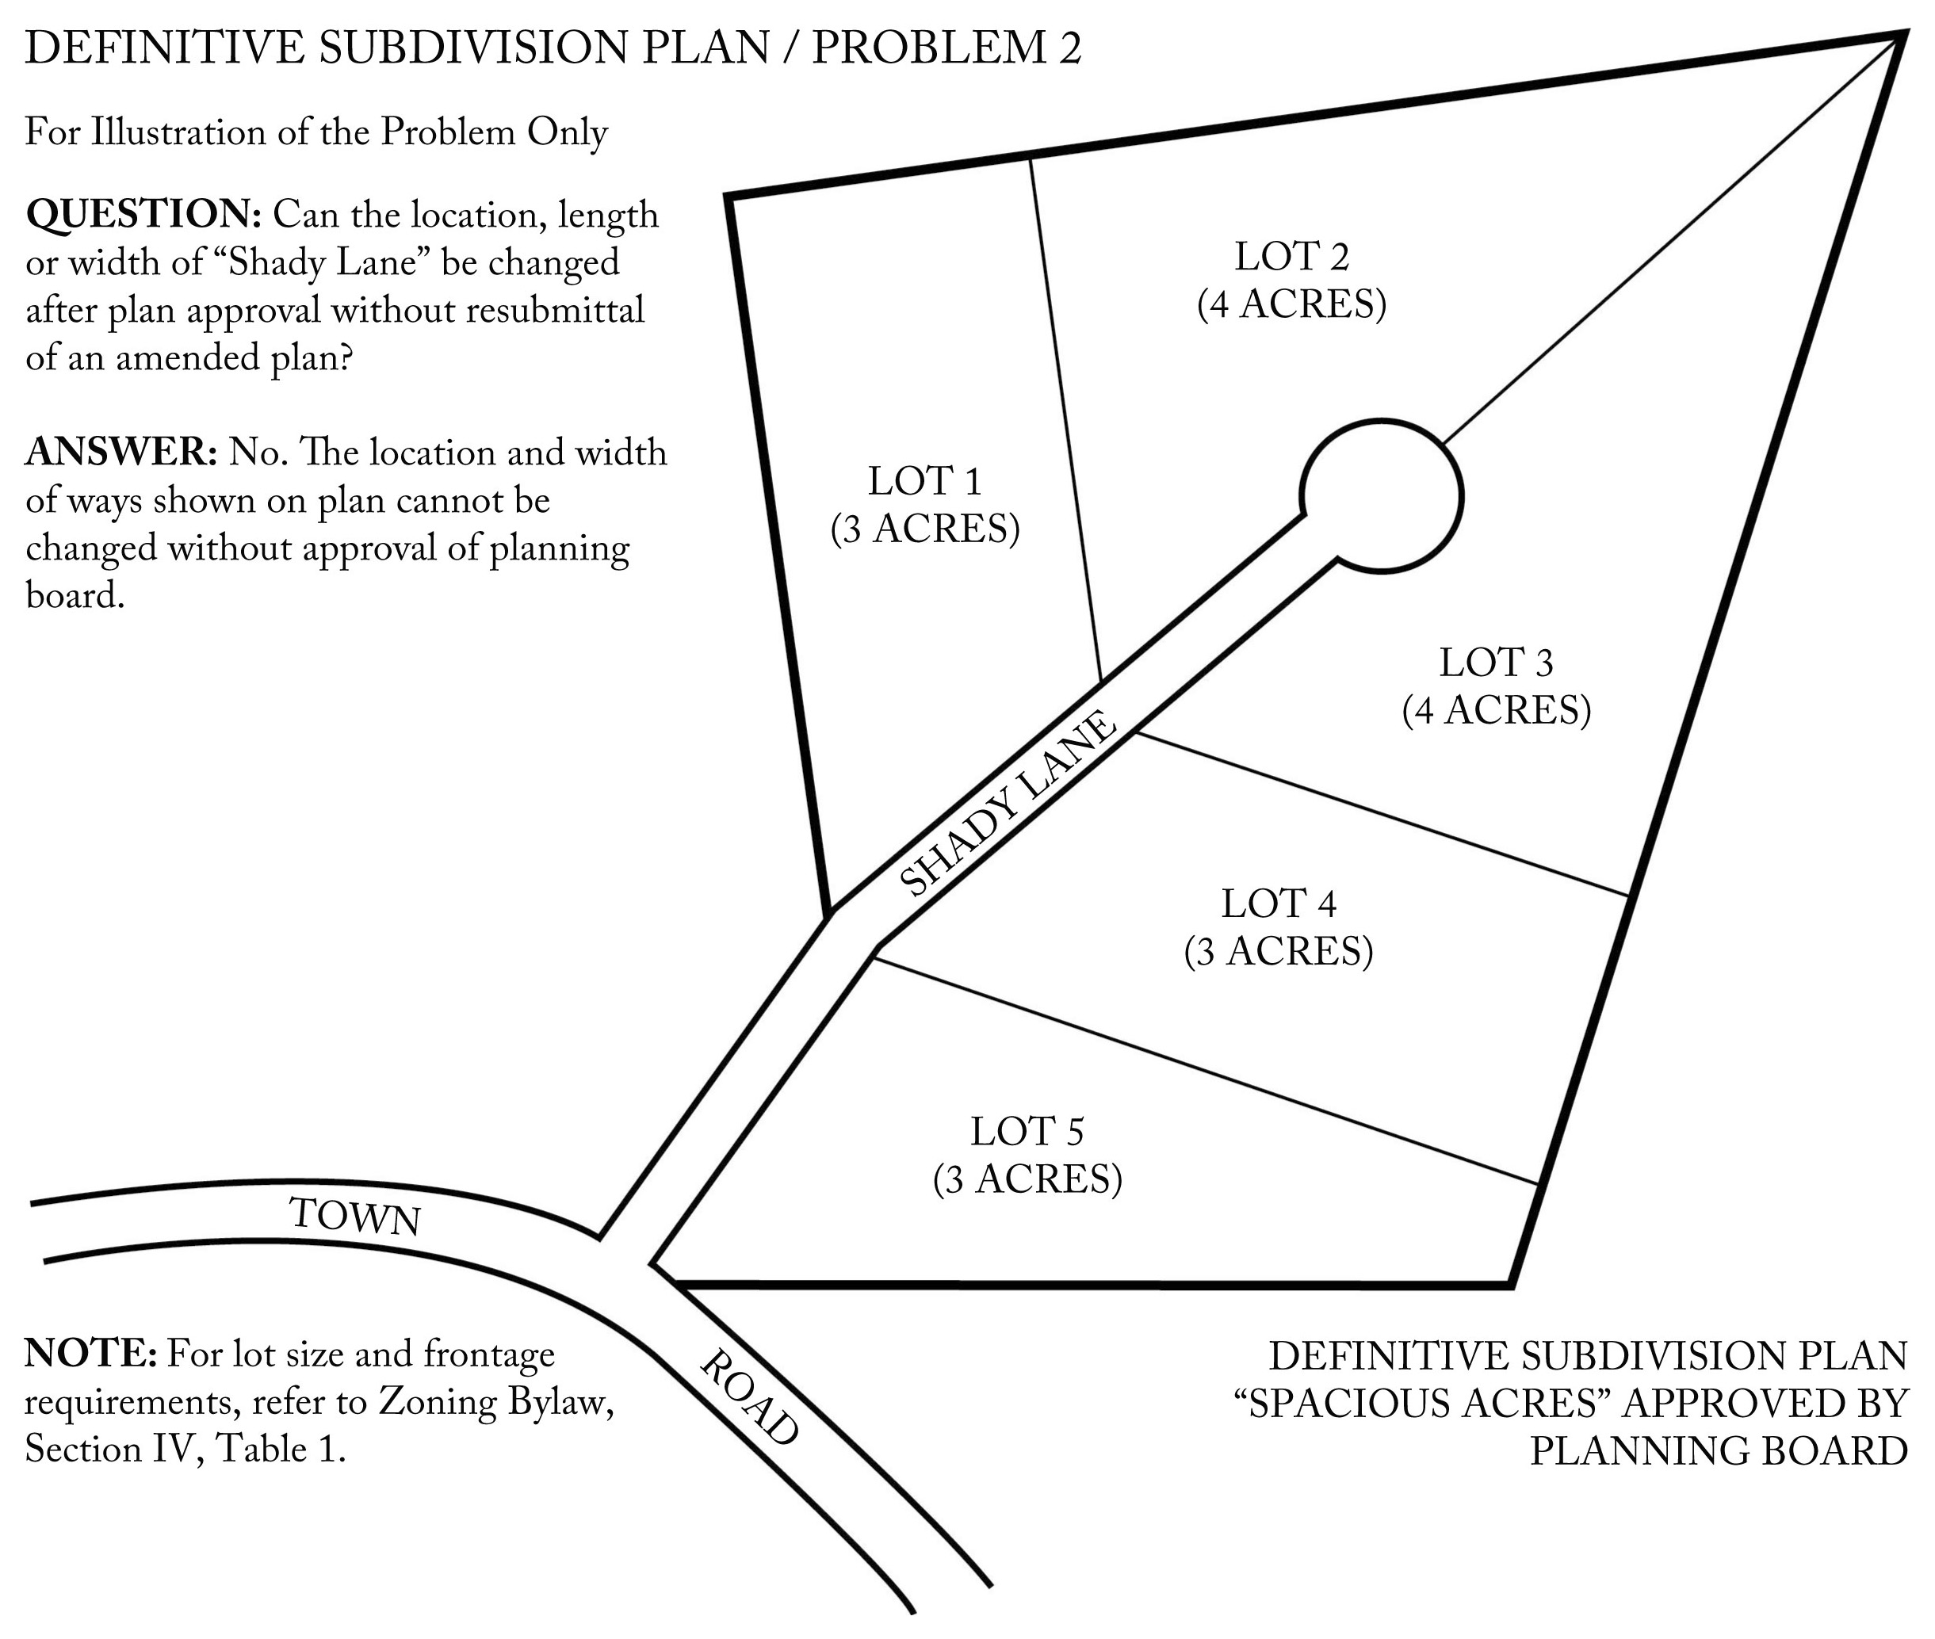
Problem 3 - Frontage and Adequate Access
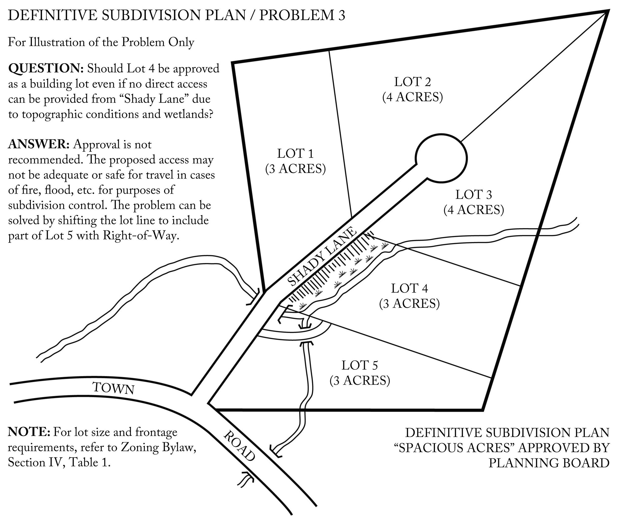

Problem 4 - Two Dwellings on a Lot

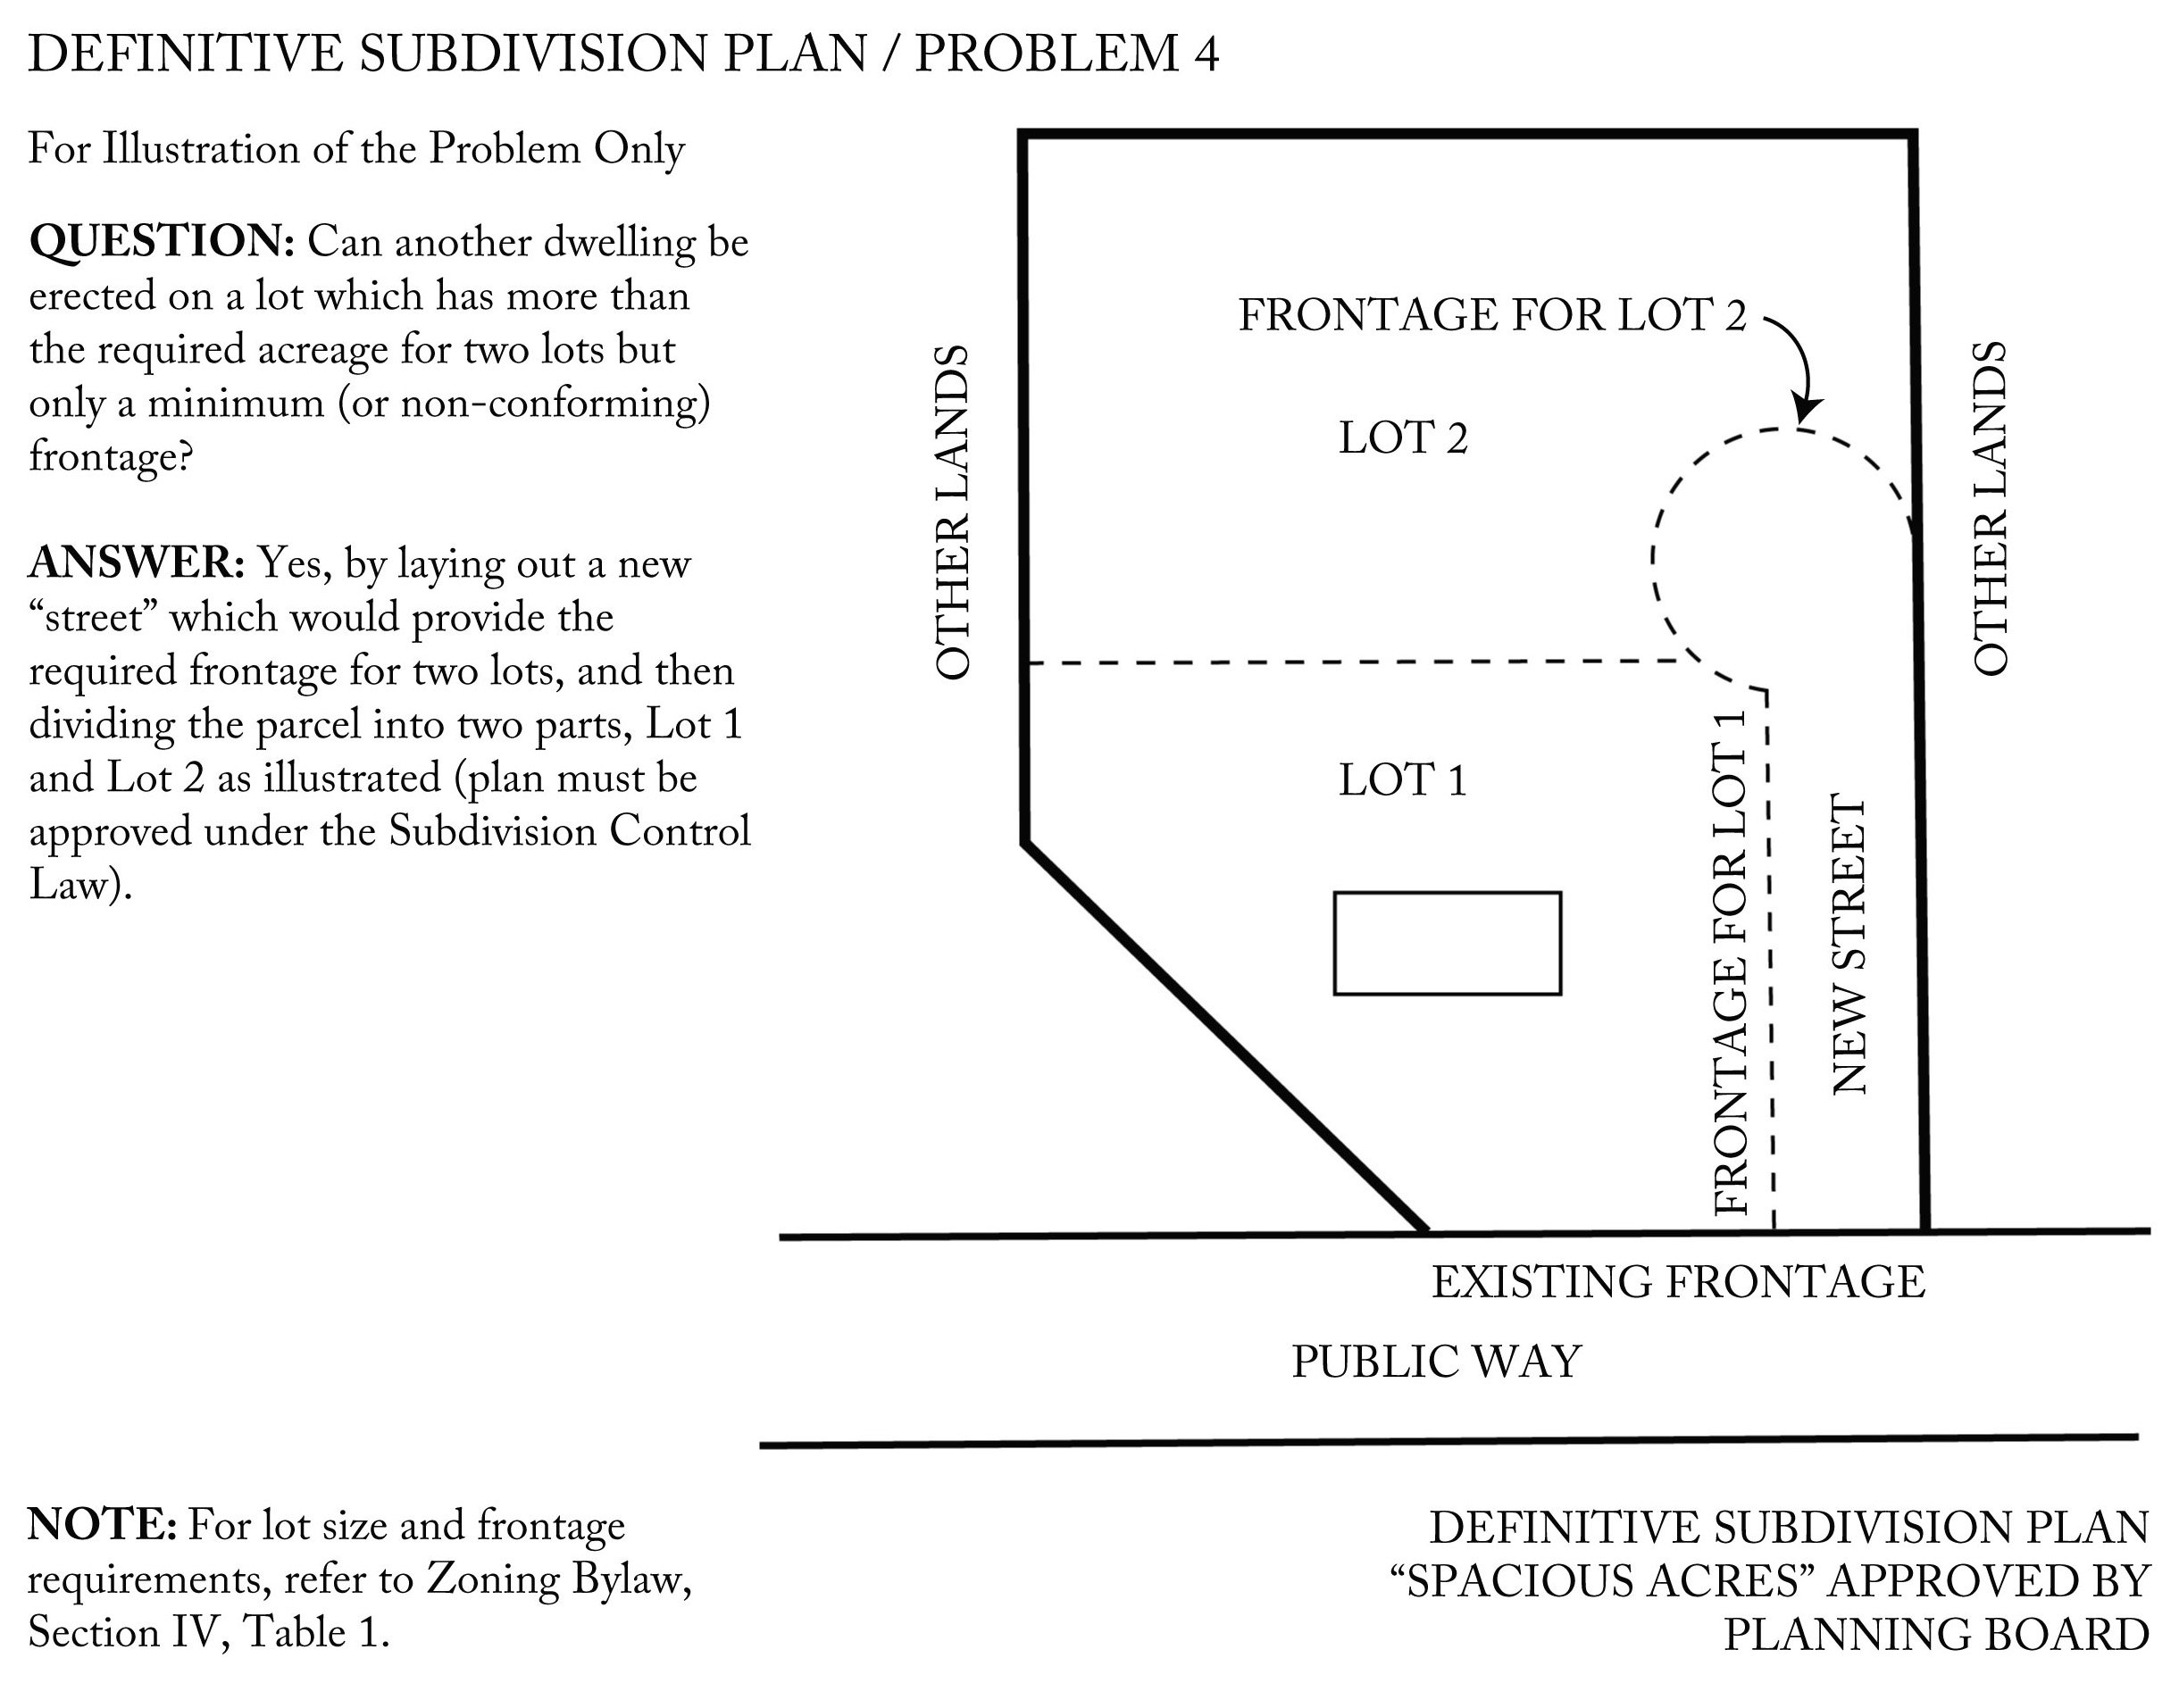

M.G.L. c 41 § 81U. Retrieved from https://malegislature.gov/Laws/GeneralLaws/PartI/TitleVII/Chapter41/Section81U

