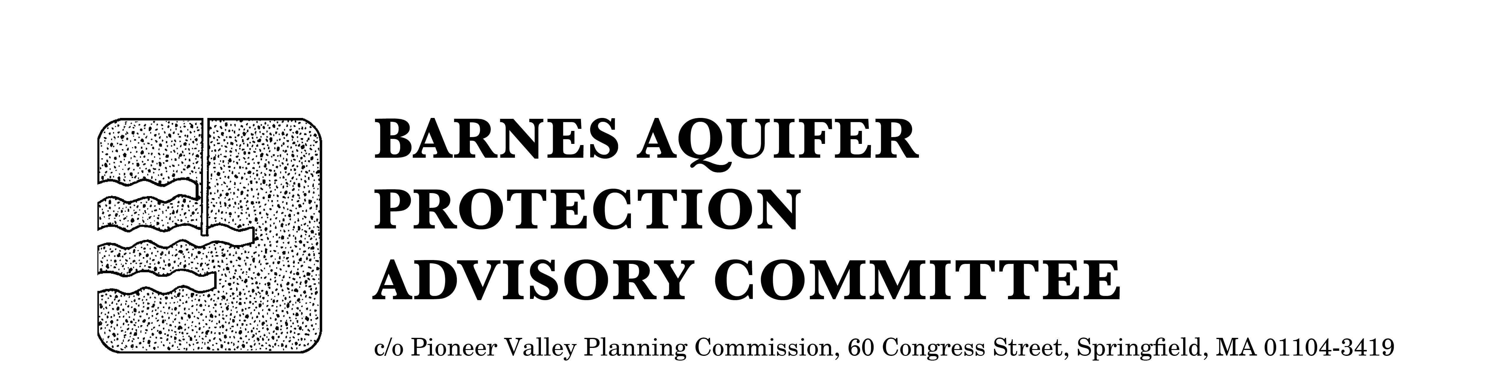

REVISED

MEETING NOTICE

BARNES AQUIFER PROTECTION ADVISORY COMMITTEE

DATE: Tuesday, May 2, 2017

TIME: 3:30 p.m.

PLACE: Easthampton City Hall (downstairs)
50 Payson Avenue, Easthampton, MA

Agenda

- Adoption of April meeting notes

- Citizen speak

- Developments of regional impact
- Southampton Solar LLC project, 41 Valley Road and 0 County Road, Southampton
- Diesel Fuel tanks (for generators) at 1110 East Mountain Road (Comcast), Westfield
- Update on PFOS and PFOA Contamination

- Work by Daniel Holbrook, Westfield State University Intern

- Updates
- Cook and County Road land acquisition
- Match funding of public engagement campaign

- Format for June meeting

- Other business

- Next scheduled meeting date: Tuesday, June 6, 3 p.m.

City/Town Clerks: Please post this notice per Massachusetts General Laws,
Chapter 39, Section 23, A-C

