Meeting Notice
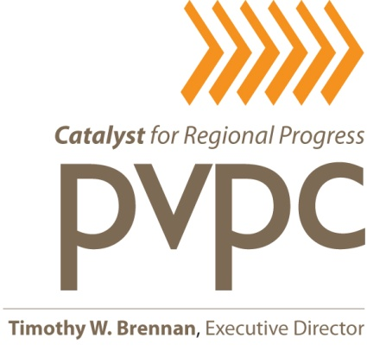
Bike Share Study
Advisory Committee

Tuesday, September 30, 2014
PVPC - Northampton Office
136 Damon Road
Northampton, MA
1:30 p.m. - 3:00 p.m.

A G E N D A

- Introductions
- Guest Speaker Sandy Fry, Greater Hartford Transit District –“Overview of Hartford Bike Share Feasibility Study” (30 minutes)

- Community mapping exercise to identify potential station locations (20 minutes)
- Final approval of project goals (10 minutes)

- Staff presentation of feasibility study chapters (25 minutes)

- Section 1: Background and Purpose of Study
- Section 2: What is Bike Sharing?
- Section 3: Existing Bike Share Programs and Alternatives for Region
- Section 4: Regional Characteristics that Support Bike Share

- Other Business / Set Next Meeting Date (5 minutes)

