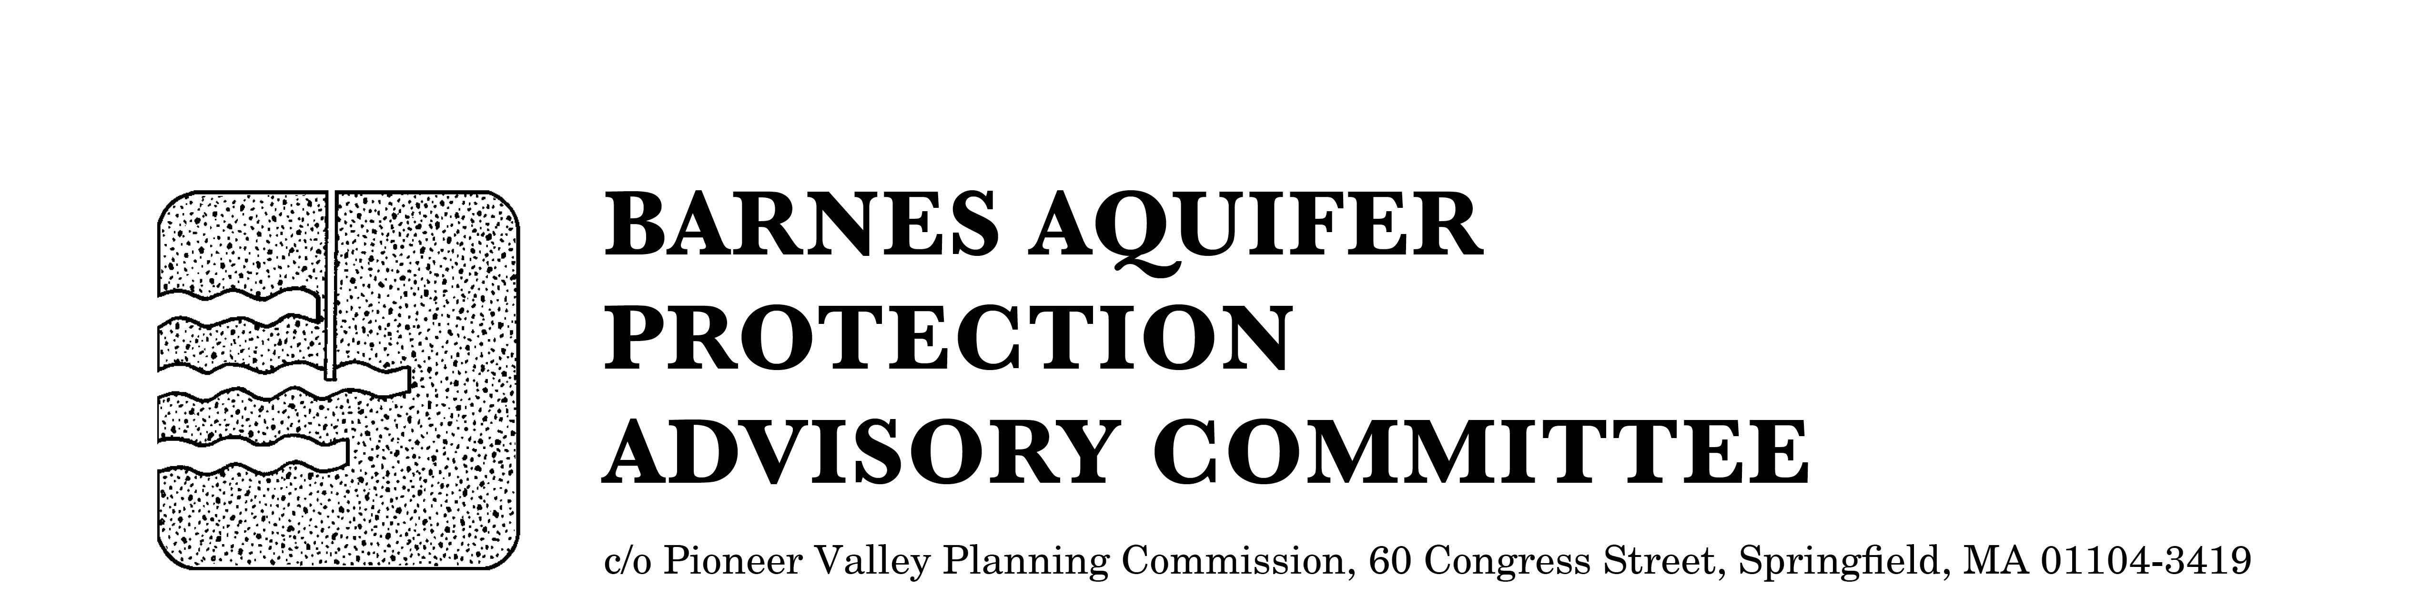

MEETING NOTICE

BARNES AQUIFER PROTECTION ADVISORY COMMITTEE

DATE: Tuesday, April 5, 2016

TIME: 3:30 p.m.

PLACE: Easthampton City Hall (downstairs)
50 Payson Avenue, Easthampton, MA

Agenda
- Adoption of meeting notes
- March 1, 2016

- Citizen speak

- Developments of regional impact
- Single family home, East Mountain Road, Westfield (Carmine Capua)
- Jarvis Surgical proposal, Westfield (Rob Levesque)
- New solar bylaw, Southampton

- Updates
- Cook Road land protection
- BAPAC studies for website
- Storm drain labels
- Outreach

- Other business

City/Town Clerks: Please post this notice per Massachusetts General Laws,
Chapter 39, Section 23, A-C

