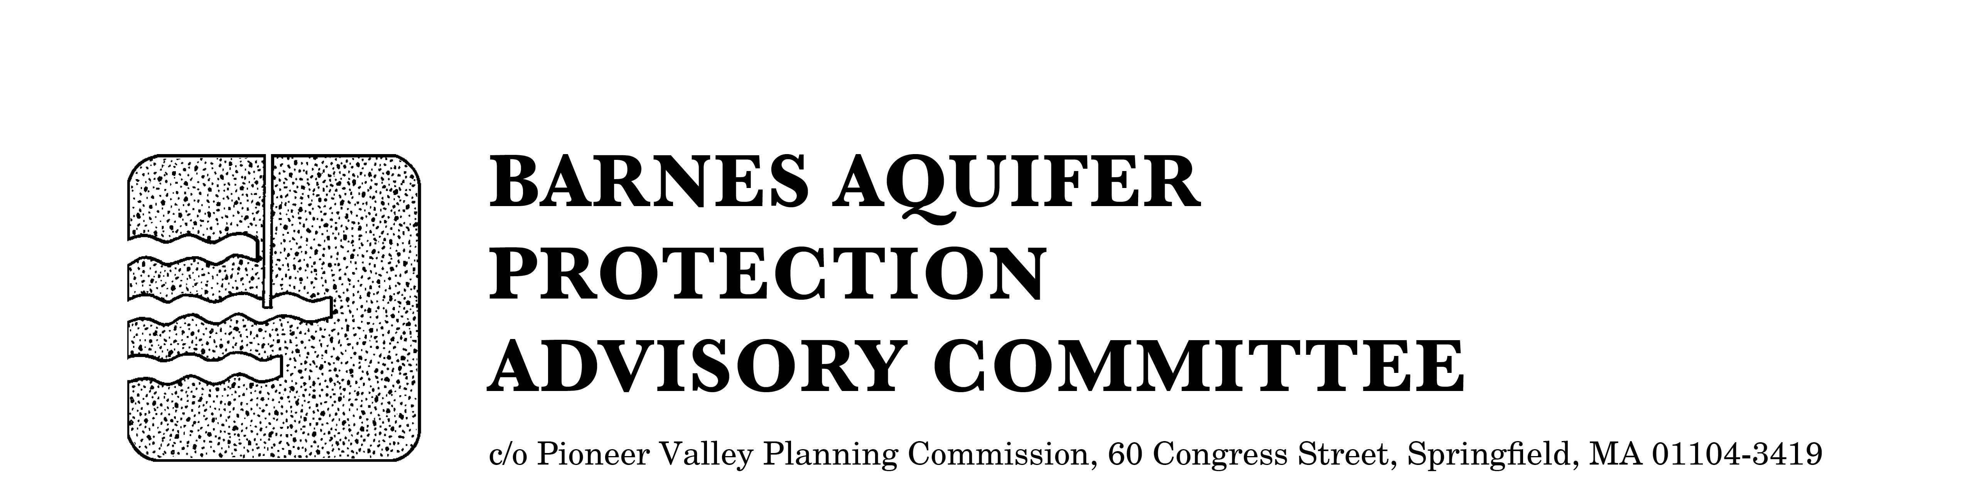

MEETING NOTICE

BARNES AQUIFER PROTECTION ADVISORY COMMITTEE

DATE: Tuesday, November 3, 2015

TIME: 3 p.m.

PLACE: Easthampton City Hall, Conference Room B
50 Payson Avenue, Easthampton, MA

Agenda

- Water Management Act (WMA) Permitting under the new Sustainable Water Management Initiative (SWMI) standards
A conversation with water department officials from West Springfield and Southwick

- Adoption of meeting notes
- October 6, 2015

- Citizen speak

- Developments of regional impact
1006 Southampton Road, Westfield - contractors' yard
Whip City Aviation, Barnes Airport, Westfield - construction of hangar
Westfield Air and Transport Museum, Barnes Airport, Westfield

- Annual report FY2014 and FY2015 and work plan for FY 2016

- Updates
- Salt study 2015
- Cook Road land protection

- Other business

City/Town Clerks: Please post this notice per Massachusetts General Laws,
Chapter 39, Section 23, A-C

