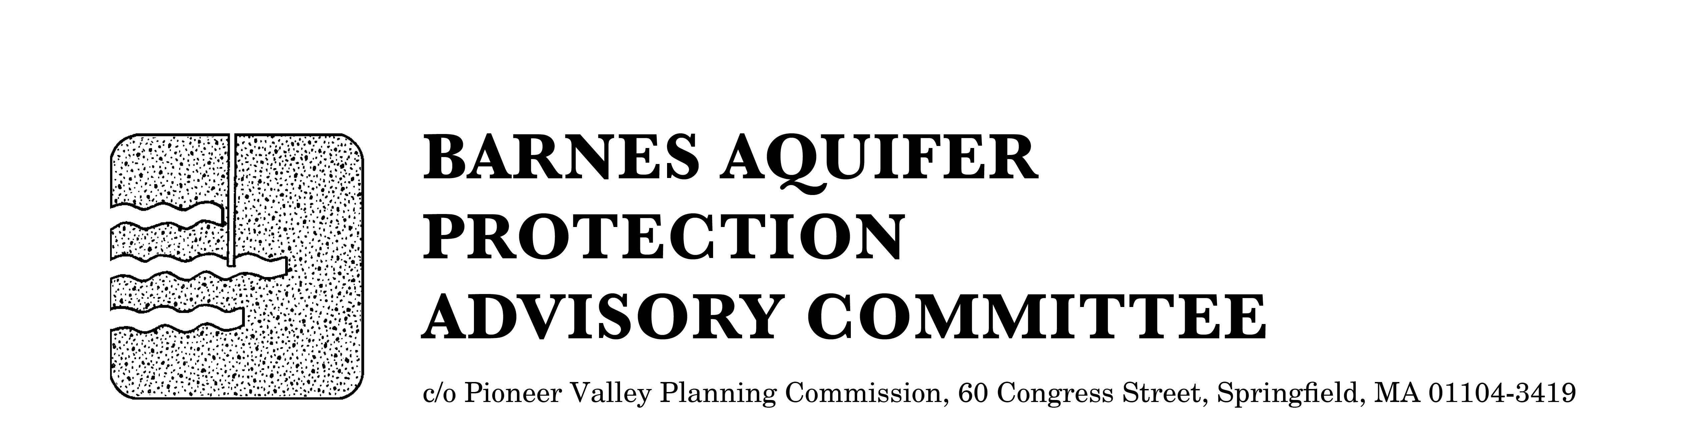

MEETING NOTICE

BARNES AQUIFER PROTECTION ADVISORY COMMITTEE

DATE: Tuesday, January 5, 2015

TIME: 3:30 p.m.

PLACE: Easthampton City Hall
50 Payson Avenue, Easthampton, MA

Agenda
- Adoption of meeting notes
- December 8, 2015

- Citizen speak

- Developments of regional impact

- Distribute FY2014 and FY2015 annual report

- Updates
- Fundraising for video
- Cook Road land protection
- Salt study

- Other business

City/Town Clerks: Please post this notice per Massachusetts General Laws,
Chapter 39, Section 23, A-C

