Mass in Motion
Healthy Market Initiative Toolkit:
A Step-by-Step Guide
2015
TABLE OF CONTENTS

Introduction

Step 1: Selecting Corner Stores

Step 2: Establishing Partnerships with Corner Stores

Step 3: Healthy Market Assessment

Step 4: Store Owner/Manager Guidance

Step 5: Store Makeover Strategies

Step 6: Evaluation

Conclusion

Mass in Motion Success Stories: Chelsea, Springfield, and Melrose/Wakefield

Useful Tools

List of WIC Offices

Website Resources

Sample Materials

Sources

INTRODUCTION

Why Healthy Markets?

The Mass in Motion Healthy Market Initiative works to improve access to healthy, affordable food and drink options at local convenience stores. The Healthy Market Initiative aims to improve access to healthy food and beverage options in areas most in need of intervention through partnerships with convenience stores that are capable of succeeding. Accessing healthy options is challenging, particularly for those living in high foot traffic, low-income neighborhoods without a nearby grocery store. Throughout the United States, low-income zip codes have 25 percent fewer chain supermarkets and 30 percent more convenience stores— which tend to lack healthy options—than middle-income zip codes. Studies have found that residents with greater access to healthy food consume more fresh produce and other healthy choices. A survey of produce availability on small neighborhood stores found that for each additional meter of shelf space for fresh vegetables, residents eat an additional 0.35 servings per day.
Key Definitions:

Healthy Eating: A pattern of food consumption that mirrors the USDA’s Dietary Guidelines for Americans, and which includes a variety of fruits and vegetables, whole grains, lean protein, and low-fat dairy.

Convenience Store: A non-specialized neighborhood store in which the majority of the inventory is food.

Healthy Market: A convenience store that is committed to meeting recommended guidelines to provide healthy, affordable options for customers.

By focusing efforts in areas of need, the Healthy Market Initiative increases the opportunity for residents to eat better. Mass in Motion Program Coordinators work with convenience stores in locations with high foot traffic (close to schools, churches, bus stops, etc.), that operate in low-income neighborhoods, and that are far from major grocery stores. After establishing partnerships with store owners and managers, Coordinators support store owners by providing helpful resources, tools, and guidance on how to turn their stores into Healthy Markets, including stocking healthier items, providing signage, and reorganizing shelves and space.
The ultimate goal of the Healthy Market Initiative is to increase the availability of healthy foods to community residents. This goal can be accomplished by following these Healthy Market strategies:

- Increasing inventory and variety of affordable fresh produce varieties and other healthy food option items in convenience stores.
- Increasing visibility and attractiveness of fresh produce and other healthy food option items in convenience stores.
- Increasing store owner knowledge about healthy foods.
- Increasing sales of fresh produce and other healthy food option items in convenience stores.

Stores in communities with challenges may encounter barriers including the store owner’s limited time, high staff turnover, the need for intensive staff support, and language barriers/ literacy challenges. Moreover store owners must first and foremost attend to their bottom line. Business owners may perceive they are receiving relatively few benefits for participating in these efforts. However, the Healthy Market Initiative is not just about health benefits for customers. Participant stores can fill latent customer demand for healthy food. They also receive considerable free publicity, expanding their reach and customer base, and increasing sales. Participation is easy, and in many cases, stores simply reorganize and feature healthy foods they already offer.

Who Are We?

The Healthy Market Initiative is part of the Mass in Motion program, housed in the Massachusetts Department of Public Health. Mass in Motion was launched in January 2009 to promote wellness and to prevent overweight and obesity in Massachusetts. The program’s initiatives serve to promote healthy eating and active living. By 2010, the program provided funding for 14 communities to implement a variety of initiatives with this aim. From 2011-2014, Mass in Motion worked with 33 programs covering 52 communities under Community Transformation Grant funding from the Centers for Disease Control. After 2014, the state legislature took over the program, which is now funded through state, federal, and private sources. As of 2015, Mass in Motion funds 27 programs covering over 60 communities across the state, including rural, urban, and suburban municipalities. The Healthy Market Initiative is part of a broader reach to increase healthy food access across these communities.

How to Use this Guide

This guide is a tool developed for Mass in Motion Program Coordinators to support the Healthy Market Initiative. The Healthy Market toolkit provides guidance to individuals who are beginning a Healthy Market campaign, who are in the initial stages of the project, or who would like more guidance and resources for established programs. This guide can and should be modified to work effectively with individual store owners and in unique communities. This guide is just that—a guide. All store owners are at different stages with their businesses and some stores will only participate in some steps. The way store owners are engaged, how assessments are conducted, and whether lofty or conservative goals are set will depend on the specific situation.
The rest of the guide is divided into several steps. They add up to a process for developing and maintaining sustainable and effective partnerships with local convenience store owners and managers. The steps are:

- Selecting Corner Stores
- Establishing Partnerships with Corner Stores
- Healthy Market Assessment
- Store Owner/Manager Guidance
- Store Makeover Strategies
- Evaluation

The first section offers a narrative description of the steps. The second section provides a set of tools Coordinators can use to carry out the Healthy Market Initiative. Also included are Mass in Motion success stories, which show many of these steps in action; resource lists; and examples of Healthy Market materials used by Mass in Motion communities.

STEP 1: SELECTING CORNER STORES

Healthy Market Initiative Coordinators will need to consider key store characteristics before selecting stores to approach for participation. Time, energy, and other resources should be directed to stores that will have the greatest impact.
The first step in store selection is to figure out where local convenience stores are located, especially in relation to grocery stores, schools, public transportation, and other relevant infrastructure. Mass in Motion’s evaluation team is available to develop maps or connect coordinators to existing maps.
The Store Selection Matrix (Step 1 Useful Tools) is a tool meant to help Coordinators decide on stores to focus on. Use the Store Selection Matrix to keep track of convenience stores and to document their characteristics. The Store Selection Matrix is completed through personal observations and information provided by the MDPH. This is a good step in which to begin to involve community members and volunteers. Getting several people invested in the health of their local corner stores early on in the process can make later steps more successful and less burdensome for Coordinators.

Suggested criteria for store selection:

- Meet the definition of “convenience store” (A non-specialized neighborhood store in which the majority of the inventory is food)
- Are located in low-income neighborhoods
- Serve populations with limited access to healthy food and/or high incidents of diet-related disease
- Are further than half a mile from a grocery store
- Are located in areas with high foot traffic and are near schools, community centers, parks, places of worship, public transit nodes, etc.
- Have an owner/manager that is open to and interested in participating in the program
- Meet a minimum level of store infrastructure (ability to accept WIC/SNAP, overall store condition, cleanliness, etc.), or have an owner/manager willing to make necessary changes

Important note: We advise that you do not take the Store Selection Matrix into the store. Doing so may put the store owner/manager on guard, which could derail the process before you have an opportunity to get to know him or her. Instead, make careful mental observations of the availability of healthy food options, as well as other aspects of store infrastructure and customer activity. Document these observations while they are fresh in your mind upon leaving the store.

The Mass in Motion Program Coordinator should also consider if the store owner will be able to meet the Healthy Market Initiative’s minimum expectations:

- Maintain high quality of produce
- Stock fresh produce: Increase the variety and quantity of produce stocked
- Stock healthy dry goods/canned goods/snacks
- Make healthy food affordable: Accept (or be in process of applying for) SNAP/EBT and WIC.
- Promote healthy foods: Display marketing materials for healthy foods.
- Comply with Board of Health regulations
- Comply with tobacco/alcohol regulations: Adherence to laws regarding sale of tobacco/alcohol to minors.

Important Note: You will not be able to complete the Store Selection Matrix in one visit. As with the entire Healthy Retail Initiative, the selection of participating convenience stores is an ongoing process. Take time to walk, bike, or drive by stores in prioritized neighborhoods to gather more information regarding location and accessibility to the community. Enter the store as a customer and gauge the owner’s and/or staff’s approachability.
STEP 2: ESTABLISHING HEALTHY MARKET PARTNERSHIPS

After completing the background work in Step 1, Coordinators should be ready to formally introduce the Healthy Retail Initiative to store owners/managers in order to choose stores to work with going forward. This guide provides a sample script used by the NYC Bodega Program for this purpose, which can be personalized for different contexts. (See Step 2 Useful Tools.)
Coordinators should get to know how the store operates and build relationships along the way. It may be difficult to completely communicate the Initiative’s purpose and potential benefits, so getting owners/managers on board may take place over several visits. Some tips include:

    - Be proactive in contacting owners/managers rather than expecting them to do the contacting
    - Ask them what the best times to visit are
    - Ask them what they need to make their business more successful
    - Identify tie-ins between business concerns and the Healthy Market Initiative; e.g., if a store owners says they need more customers, suggest free or low-cost advertising methods to promote healthy foods
    - Be patient, as it might take several visits to accomplish a goal

The Mass in Motion Owner Interview Tool (Step 2 Useful Tools) is a way to determine a store owner’s willingness to participate in the Healthy Market Initiative. An owner that shares the values of healthy eating and healthy community is an important ally in successfully implementing the Healthy Market Initiative. The Interview will also start to identify challenges and ways Coordinators can be the most help to owners. Please note the Mass in Motion Owner Interview is not an assessment. It should be used as a guide to engage in conversation with the store owner and to gauge his or her interest and willingness to participate in the Healthy Market Initiative. The Store Owner Fact Sheet (Step 2 Useful Tools) can be left behind so the store owner can review the information on the Initiative again on his own time.
Conversations with the store owner should be two-way. The more Coordinators are able to listen for what the store owner has to say about the community, healthy eating, and stocking healthier foods, the better the relationship. It is also important for the owner to realize that this is a local initiative based in their community. Working with volunteers or interns, especially those who live in a corner store’s neighborhood and who may already be customers, is a valuable way to gather information. Their familiarization with the neighborhood and store can gain store owners’ trust more quickly, and may lead to more success.
The Boston Public Health Commission’s Boston Healthy on the Block Project has successfully used the following strategies to sell the program to convenience stores:

- Suggesting smaller strategies that are relatively simple to implement but have dramatic impact. For example, stores could add a new display for healthy food they already sell.
- Offering free marketing strategies and materials and emphasizing the opportunity for higher sales.
- Highlighting the important role the convenience store plays in creating a healthier community. Coordinators can talk about health problems and create a space for owners/managers to share how those health problems may have affected them or those they know.
- Stores might be eligible to get assistance for improvements from municipal and other state government offices or private foundations. The Mass in Motion Program Coordinator can help the owner find funding opportunities.

Additionally, it is helpful to address the issue of customer demand. Some market owners might perceive a lack of demand for healthy food as a barrier. Strategies for providing evidence that customers want healthier items include surveying customers and neighborhood residents or providing customers with a way to request healthy items, such as a postcard campaign. Buying some healthy items, if they exist, when visiting can also serve to strengthen the case for demand.
Once the store owner has agreed to participate, a Healthy Market Agreement (a Memorandum of Understanding) will need to be signed by the Program Coordinator and the store owner. This agreement is important because it will outline the partnership between the Mass in Motion Program and the convenience store. It should highlight the activities the Program Coordinator will provide in return for the convenience store owner implementing the Healthy Market criteria. A sample agreement is included with the Step 2 Useful Tools.

STEP 3: HEALTHY MARKET ASSESSMENT

Once a store owner has agreed to participate in the Healthy Market Initiative, the Mass in Motion Program Coordinator will schedule and conduct an initial assessment of the convenience store. Coordinators should schedule the Mass in Motion Healthy Market Assessment (Step 3 Useful Tools) at a time convenient for the store owner. The Assessment will serve as a baseline for identifying the variety and quality of produce available in the store pre-intervention, as well as opportunities for better marketing of produce and other healthy foods. The Healthy Market Assessment takes 10-15 minutes to complete.
The Program Coordinator should use the initial Healthy Market Assessment as a tool to develop store-specific enhancement strategies and to set appropriate goals based on the attached Healthy Market Guidelines (Step 3 Useful Tools). The Step 3 Useful Tools section also offers further guidance on how to use the Assessment.
Meet with the store owner/manager to share results from the initial Assessment in context with the Healthy Market Guidelines. Prepare a 1-page summary that emphasizes both “positive findings” and “places to grow.” With the store owner, review the Healthy Market Guidelines and decide which areas to prioritize (i.e. fruits/vegetables, healthy cereals, grains, healthy snacks, etc.). Make an initial Project Plan (Step 3 Useful Tools) with the store owner that includes their individual goals, potential strategies to reach goals, and key resources, and refer back to this Project Plan as time goes on.

STEP 4: STORE OWNER/MANAGER GUIDANCE

In order to be successful, the store owner will likely need technical assistance from the Mass in Motion Program Coordinator in a variety of areas related to stocking healthy food options. Connecting store owners to produce vendors and distributors will be a great help since many may not be familiar with ordering produce. Local farms, farmers market-to-store programs, distribution centers, and co-ops could be explored as options. A produce consultant can be a great resource for store owners. When choosing a source of produce the owner/manager should consider cost, delivery schedule, order size requirements, and product quality.
Many store owners may not know how to order, handle, care for, or display fresh produce, although they already have valuable business knowledge. Coordinators can build on this knowledge and offer resources to increase store owners’ comfort level with the new products. Mass in Motion Program Coordinators may need to provide support around the following:

- Properly inspecting and handling all produce upon purchase and delivery to ensure highest quality
- Storing produce appropriately (refrigeration, storing non-refrigerated produce away from hot areas and off the floor to maintain good air circulation)
- Checking produce regularly to remove rotting items
- Displaying older produce first to make sure it sells before newer merchandise
- Keeping produce areas clean and appealing

Many store owners may do little bookkeeping. The Mass in Motion Program Coordinator can help establish simple methods (non-computerized or computerized, depending upon the owner’s skill level and preference) to track orders, sales, discard, etc. These tools can be used by the owner to evaluate the success of the business change. Experience in the field has shown that some owners may not feel comfortable sharing their books, though the relationship between owner and Coordinator will influence this decision.
The Program Coordinator (or other local professional) may also need to spend time going over nutrition basics with the store owner, as well as the importance of reducing chronic disease rates in his or her community. Increasing the store owner’s understanding of nutrition will also increase their understanding of the Healthy Market Initiative. (See links at the end of this document for nutrition education resources.) The Mass in Motion Program Coordinator will start to become familiar with a store owner’s knowledge after conducting the interview, and can gauge the level of conversation from there.
In summary, frequent visits and collaborative oversight by the Mass in Motion Program Coordinator are required to earn the owner/manager’s trust and make the Healthy Market Initiative a success. Flexibility is essential and finding time to meet with the store owner may require meeting before the store opens, after it closes, or waiting patiently as they take care of customers. Willingness to listen to the store owner and work with them in partnership is also key. The best strategy is often to let the store owner take the lead, offering guidance whenever needed. The Store Owner Retail Reference Guide (Step 4 Useful Tools) should be left behind at the corner store.
STEP 5: STORE MAKEOVER STRATEGIES

A critical element of any Healthy Market is setting up the store in a way that helps promote healthier options, based on the store’s context. While the Assessment of the store is occurring, Mass in Motion Program Coordinators should begin thinking about the types of store layout changes that would be most effective and how to leverage existing infrastructure to make these improvements.
Basic store enhancement strategies include two main components: 1) Store Layout and Infrastructure Improvement and 2) Signage

1. Store Layout and Infrastructure Improvement

A clean and visually appealing store can be helpful in supporting a Healthy Market. Several strategies for improving the layout include:

- Helping owner/managers clean, de-clutter, and freshen up their stores. Customers tend to visit clean stores where they feel safe. Many store owners wear multiple hats including customer service, management, accounting, janitorial, etc. and often do not have time to make improvements in their stores. Identifying resources and ideas to improve the physical appearance of the store and providing support to tidy, clean, paint, and reorganize can be a major incentive to some owners to join the program.

- Locating produce displays at the store entrance. Inexpensive baskets can be procured and used to attractively display healthy items such as fruits and veggies and other non-refrigerated items.

- Creating “Healthy Zones” where healthier items are grouped into easy-to-identify displays. Refrigeration units can be reorganized to clearly display healthy items, including placing healthy items closer to eye-level in the mid-section of the unit and unhealthy items lower in the unit. Dedicate a section of the store to kid-friendly signs and healthy snacks, such as fruits and vegetables, granola, and healthy lunch box options. Move away from aisles to create a “lunch zone” and a “dinner zone.”

- Removing or relocating signage from windows that block natural light and/or promote unhealthy items. The Program Coordinator can serve as a consultant for the owner/manager in making sure that healthier items are displayed and highlighted in the best way.

- Placing “grab and go” items such as bananas and other fruits at the point of purchase and putting less healthy food in the back of the store, if possible. If healthy items are not moving in the store, perhaps the owner has not considered placing them in the same proximity as candy and gum.

- Clearly marking prices on all produce and healthy items. This type of price comparison is important because customers will be able to see that healthier choices may actually cost less than less-healthy choices.

There are other, more intensive options for enhancing convenience stores, including improving lighting, storage space, refrigeration, pricing, and façade enhancements. Some communities have additional funds available for retail store enhancements; check with local economic or community development departments (and see list of website resources at the end of this guide). If available, funding from other sources can be used to:

- Purchase refrigeration and storage for the stores to hold additional produce
- Replace old shelving
- Paint the store façade to improve curb appeal
- Replace old lighting or add additional lighting within the store

Because the store makeover is an important part of the process of a convenience store strategy, the Mass in Motion Program Coordinator may want to consider working with a grocery store consultant who can provide expertise in displaying, marketing, pricing, and handling fresh produce and other healthy options. If resources are not available for a consultant, some ideas to consider include:

- Placing healthy items at eye level and unhealthy items above or below eye level
- Grouping items that complement each other together. Grocery stores tend to place related items together to entice customers to buy more. (Pasta and spaghetti sauce are an example.) The Mass in Motion Program Coordinator can work with the owner to place healthy items that tend to be cooked together (e.g., rice and beans) in the same area
- Placing less-healthy items at the back and healthy items near the front of the stores

2. Signage

Most customers may not be aware that their stores carry healthier foods if their attention is not actively drawn to the healthier options. Signage needs to clearly market/promote the healthier foods. Effective signage should include:

- Large, easy to read signs that identify the healthy items being promoted. Signs may include window clings, sidewalk signs, shelving signs
- Additional information including nutritional value, ingredients, or recipes
- Special promotional signs to advertise sales

MDPH has developed materials around nutrition, sodium, and Mass in Motion that store owners can use in their stores. They can be ordered from the Massachusetts Health Promotion Clearinghouse at www.maclearinghouse.com.
Changes to the store will help support marketing and promotion of healthy items. Other ways to promote healthy options include distributing recipe cards that feature foods in the store, hosting nutrition education events, or having a veggie or fruit of the month event that may include offering a discount on the purchase of featured items, as well as recipes based on the item. Tasting events are a popular way for customers to sample healthy prepared foods that are available in the store.

MDPH provides a Healthy Market Options decal that can be customized for Mass in Motion Program Coordinators. This decal can be used for the door or window of stores that meet the criteria, as well as any signage that highlights healthy options. See Step 5 Useful Tools for an overview of the process.

STEP 6: EVALUATION

It is recommended that the Mass in Motion Program Coordinator perform regular assessments of Healthy Market strategies in participating convenience stores. The Mass in Motion Program Coordinator can review the results of the assessment each year to determine if the store is meeting the project expectations outlined in the MOU (see Step 2) and to review progress made in the store’s annual Project Plan. The Mass in Motion Program Coordinator can then meet with each store owner to review the results of the annual assessment and outline the store’s progress toward achieving goals. This meeting will serve as an opportunity for the store owner and Coordinator to review and update the store’s Project Plan to set new goals if necessary.
The progress of the Healthy Market Initiative ongoing. In addition to the formal Assessment of the convenience stores, Mass in Motion Program Coordinators are encouraged to document the action steps taken to execute Healthy Market Initiative strategies. It is important to document the strategies and steps that work and don’t work in order to improve program processes and implementation. A Process Measures worksheet (Step 6 Useful Tools) is available to organize this documentation.
Mass in Motion Program Coordinators should consider reporting any challenges and barriers to program implementation as well as technical assistance needed to their Community Liaison. The Coordinator is also encouraged to visit the store owner regularly to check on progress, answer questions, and provide assistance with program implementation. These visits will serve to strengthen relationships with store owners in addition to serving as ongoing opportunities to determine the overall needs and update the individual goals of each store.

CONCLUSION

The Mass in Motion Healthy Market toolkit should be used uniquely in each community. The overall framework in the toolkit is pulled from best practices in the field, and lessons learned from Mass in Motion communities that have already started on this work, yet each step and tool can be modified according to a community’s needs.
This toolkit focuses primarily on the addition of healthy foods in stores, and the de-emphasis of unhealthy foods. However, the health of a small market is also related to the presence of tobacco, alcohol, and other drug products. Moving forward, Coordinators may want to think more about adding in Alcohol and tobacco questions have been added to the Healthy Market Assessment tool (Step 3 Useful Tools) as an example of a way to incorporate more information about these products into recruitment, strategies, and evaluation. A more holistic understanding of a healthy corner store means healthier choices for all residents.

SUCCESS STORIES

Chelsea

Background
Healthy Chelsea’s corner store program began with research funding from Massachusetts General Hospital. The funding was aimed at determining the impact of increasing availability of produce in corners stores on the dollar amount of WIC checks for produce spent at the stores. For three months, staff built relationships with stores, administered 300 surveys, and conducted three focus groups with community members in order to gather information about the types of products people were looking for at corner stores. Healthy Chelsea ultimately chose three intervention stores and three control stores for the study, giving each $1500 in three stages (Pre-Survey, Midpoint, and Post-Data Collection). Staff collected data over a period of six months. In the intervention stores, they implemented a variety of changes, including new infrastructure and bilingual signage for healthy products. Making changes to the store was a source of pride for at least one store owner.

What worked
- In one store, a large snack display was moved from the middle of the entryway to the side, while simultaneously providing new stands and baskets for a fruit and vegetable display at the front.
- A second store moved two shelves of pastries up higher and replaced them with fruits and vegetables. Healthy Chelsea provided two-tier baskets and plastic bins to organize produce on the shelves and in refrigerating units. They also cleaned an already-existing wooden produce stand.
- Staff found it was crucial to visit a store many times, forming a partnership with each corner store and practicing flexibility with components of the program. They kept in mind that the store ultimately belongs to the owner.
- Pointing out that produce offers a greater profit margin than snacks made the initiative more attractive to store owners.
- Providing training and technical assistance around how to manage produce to avoid problems with perishability is helpful. Healthy Chelsea used a healthy retail consultant who previously worked with East Boston and Mattapan communities that took part in the Boston Healthy on the Block program.
- Offering a short-term program was appealing to owners because it felt like a lower risk, though all three intervention stores signed up to continue working with Healthy Chelsea.

What was challenging
- Chelsea found data collection challenging at times. One of the store owners lost his ability to accept WIC and SNAP, which severely impacted his store’s ability to remain open; a control store also lost its WIC/SNAP licensure and closed. Additionally, during the focus group stage, two sessions were sparsely attended. Staff found that the group held closer to the end of the month was more heavily attended, possibly because the $25 Market Basket coupons they gave out meant more to participants who were running out of SNAP funds.
- Storing produce consistently and keeping it fresh was another major challenge. Store owners would sometimes not keep produce stocked, and found it difficult to maintain during hot summer months when it would go bad quickly. Without expensive air conditioning, fruits and vegetables rotted or were hidden in refrigerators.
- The enthusiasm of the store owners waxed and waned inconsistently, which required regular check-ins to make sure produce was being stocked.

Next steps
After the study ended, Healthy Chelsea planned to use funding to extend the intervention pieces to the three control stores. The three intervention stores signed memoranda of understanding to continue their participation as healthy corner stores. Eventually, they intend to expand the program to an additional four corner stores. Chelsea has an estimated 30 to 35 corner stores, so a lot of work remains. During future work, they will have to make difficult decisions with regard to funding, balancing spending a lot of money at one store to add expensive equipment versus spreading the money out over smaller projects at many stores.

Springfield

Background
The Springfield Healthy Corner Store Initiative has nine participating stores. Within each of the stores, they have labeled healthy foods, hung posters, and made small changes to the existing infrastructure in order to promote the sale of healthier products. They also pursued additional methods for offering healthy food, such as talking to distributors about what they stock and sourcing from farmers markets. Springfield staff approached this work with the goals of facilitating conversations between customers and store owners, helping customers feel like they had a voice in what was sold in their neighborhood store, and helping minimize the store owner’s risk of trying to provide foods that would not sell.

What worked
- Springfield has taken a two-pronged approach to healthy corner stores, working on both the supply and demand side since owners need a business reason to stock produce. For example, staff conducted a survey of 150 passersby and employees at a local bus station and learned there was significant demand for fruit at the station’s corner store. Given this information, they convinced the owner to stock healthy products.
- Nutrition education nights at the corner stores brought potential customers together with corner stores. In stores with ample space, they prepared dishes with ingredients that could be found on the shelves for taste testing and handed out recipes. In smaller stores, they demonstrated the amount of sugar in each of the top-selling sugar-sweetened beverages to start conversations about healthy food.
- Springfield offered a short, five-question survey asking customers whether they would buy healthier products like whole grains, snacks, and drinks, and if so, what specifically they would purchase. The results were disseminated to store owners to help them feel more confident about stocking particular products. Springfield asked each storeowner to pick two items from the list of most commonly mentioned products and stock them, which was done by two stores.
- Springfield has worked hard to develop strong relationships with store owners. They employed interns to visit corner stores weekly for about three months before asking for any large changes. Two of the interns were community members who were already customers of the stores they were assigned.

What was challenging
- It was challenging to get a full understanding of where the food in the corner stores comes from because owners procure products from such a variety of sources. Springfield has responded to these issues by looking at ways to work directly with distributors and trying to find a shared warehouse or location for the stores to cooperatively buy and store healthier products. They are developing their relationship with the mid-size Pride supermarket chain in Springfield in the hopes they can offer the use of their distributor or store healthy food on behalf of the corner stores.
- The healthy food labeling system has been a challenge. The labels have stayed in place in the stores, but products are moved around, so many of the healthy labels have inadvertently marked unhealthy products.
- Store owners sometimes believe that the Mass in Motion staff are inspectors from the health department, there to evaluate or monitor them, creating tension.
- Evaluation of the overall program has proven challenging because most corner stores do not track the sales of specific items and because owner turnover is common among corner stores.

Next steps
Springfield believes incentives will be crucial as healthy corner store programs move forward, whether those incentives are financial, business training, or infrastructure changes. They have considered an Adopt-a-Store model as they move forward with this work in order to create more sustainability. Under this model, community organizations in the neighborhood would take over much of the work.

Melrose/Wakefield

Background
The Melrose/Wakefield Mass in Motion team developed a Healthy Corner Store Program in 2012 using the MDPH Healthy Market Toolkit. They spent about six months planning before they went into the corner stores. The team chose their initial stores based on their proximity to schools and other important locations, in addition to the store owner’s interest in participating. By the end of 2014, eight stores were enrolled: four in Melrose and four in Wakefield. Ultimately, their model included a store assessment, an owner interview, a healthful product inventory, and PR blitz in the local media on behalf of the store. In the following months, the Mass in Motion team visited each store periodically in order to provide support.

What worked
- The initiative was driven both by a small group of community members developing the program and making it specific to each community, but also by individuals who formed relationships with stores. It was important for the corner store owners to see one consistent face over time, to facilitate changes more easily.
- Melrose/Wakefield has been especially successful in terms of quick recruitment and long-term retention of stores. After 107 total visits across all stores, they recruited eight stores to participate in the program.
- Healthy products have been selling in participating corner stores. In particular, many of the stores reported high sales of bananas and pomegranates. They provided many of the stores with baskets to fill with produce and put on the checkout counters.
- Working with stores that already sold at least one healthy item—and acknowledging and thanking the owners for this— was helpful. Melrose/Wakefield was able to build on what the stores were doing, pushing them in the right direction and working them to expand their selection.

What was challenging
- It was an ongoing challenge to create a sustainable system for keeping fresh fruits and vegetables in stock and selling them.
- Changes in funding from Mass in Motion (i.e. losing CTG funds) led to fluctuations in how much time and energy Melrose/Wakefield spent on store recruitment.
- Staff experienced some distrust from store owners at first, who did not understand that the initiative is not a health department or inspection program.
- There has been no formal mid-point evaluation process, and little time for follow up now that time has passed after initially setting up the Healthy Markets.

Next steps
Melrose/Wakefield will continue healthy corner store work in order to reach more of the 26 total corner stores in the two communities. Staff are interested in working with teens to conduct assessments with their peers, recommend youth-friendly products, and suggest placement for healthy items. Since the program has already worked with many of the corner stores they have identified as being more amenable to healthy changes, Melrose/Wakefield anticipates challenges moving forward and working with corner stores that have higher barriers to participation.
TOOLS

Step 1 Useful Tools
- Store Selection Matrix

Step 2 Useful Tools
- NYC Healthy Bodega Initiative “Sample Script”
- Owner Interview
- Store Owner Fact Sheet
- Sample Healthy Market Agreement

Step 3 Useful Tools
- Healthy Market Guidelines
- Healthy Market Assessment
- Healthy Market Assessment Guidance
- Sample Project Plan

Step 4 Useful Tools
- Store Owner Retail Reference Guide

Step 5 Useful Tools
  - Guidelines for Printing Healthy Market Decals
  - Press Release Template

Evaluation Tools
      - Process Measure Worksheet

Step 1, Useful Tool 1

Store Selection Matrix

Mass in Motion Healthy Market Initiative: Store Selection Matrix
Criteria | Store Name | Store Name | Store Name
Location and Access
General Location (neighborhood)
% of population in poverty
Nearest type of school (ES/MS/HS) and distance to school
Distance to nearest convenience store
Distance to nearest grocery store
# of bike racks
Near Intersection with crosswalk | Yes/No | Yes/No | Yes/No
Parking | Yes/No | Yes/No | Yes/No
Accessible by Public Transit | Yes/No | Yes/No | Yes/No
Store Infrastructure & Business Activity
Accepts SNAP/EBT? | Yes/No | Yes/No | Yes/No
Accepts WIC? | Yes/No | Yes/No | Yes/No
Sells fresh produce? | Yes/No | Yes/No | Yes/No
How is fresh food displayed? (i.e. off the ground, broken boxes)
Proper refrigeration for perishable foods? | Yes/No | Yes/No | Yes/No
Overall store condition? (lighting, shelving, windows, floors, etc. | Good/Average/Poor | Good/Average/Poor | Good/Average/Poor
Merchant/Store Characteristics
Owner/Clerk/Staff approachable? | Yes/No | Yes/No | Yes/No
Owner/Clerk/Staff responsive to you and other customers? | Yes/No | Yes/No | Yes/No
Who comes into store? (Circle all that apply) | Families/Youth/ Adults/Seniors | Families/Youth/ Adults/Seniors | Families/Youth/ Adults/Seniors
Store owner's interest (see Owner Interview tool) | High/Med/Low | High/Med/Low | High/Med/Low
Store owner invested in community?(see owner interview tool) | High/Med/Low | High/Med/Low | High/Med/Low
Additional Comments (note cleanliness and clutter of store and other observations you deem important)

Step 2, Useful Tool 1
NYC Healthy Bodega Initiative “Sample Script”

Hello my name is _________________and I (live, work, go to school) in this neighborhood. Is the owner or manager available?

- If owner IS NOT available, find out the best day and time to reach him/her and return to the store then.
- If the owner IS available, continue below…

My (family, friends, coworkers) and I are regular customers here. We like your store and come often because it’s close to our (home/school/work).

We like to eat healthfully, but noticed that it is often hard to find healthy foods in this neighborhood. We’re here today to ask you to make some small changes in your store’s inventory. We’ll support you in the changes you make and encourage others to buy the healthy new items you offer. Would you be willing to stock healthier options such as low fat milk/apples/low fat yogurt/whole grain bread/etc.?

(If you receive a positive response…) That’s great! When would be a good time for me to come back so that we can talk about working together to support and promote your bodega? During this visit, I’d like to check out your store inventory and see what healthy foods you currently stock and where there’s room for improvement.

You and your store are an important part of our community. Thanks for what you do and we look forward to buying healthy items here in the future!

Step 2, Useful Tool 2
Owner Interview Tool

Adapted from NYC Healthy Bodega and Boston Healthy on the Block

Convenience store name: | Today’s date:
Convenience store address: | Your name:
Owner contact information (phone, email):

- How long have you owned/managed this store?

- Who shops here the most frequently? (For example, people who live in the neighborhood, older adults, middle or high school students, people who work in the area?)

- What percentage of customers use SNAP/WIC?

- How do you decide what to carry in your store?

- What are the top three selling items in your store, including non-food items?

a.___________________________________________________________________

b.___________________________________________________________________

c.___________________________________________________________________

- What are the top three healthy food items sold in your store?

a.___________________________________________________________________

b.___________________________________________________________________

c.___________________________________________________________________

- How much of a demand is there for fresh produce? (Have you heard from customers who want to buy fresh produce?)

□ None
□ Little
□ Some
□ Substantial

- Are there any healthier food items you’re interested in selling?
□ Yes If yes, what are they? ________________________________________________________
□ No

- What makes it hard to carry more healthy food items in your store?

- How can we best help you to offer and sell healthier foods?

- How interested are you in the health of the community?

□ Very interested
□ Somewhat interested
□ Not very interested

- How involved would you say your store is in the community?

□ Very involved
□ Somewhat involved
□ Not very involved

- How open would you say your store is to working with community members?

□ Very open
□ Somewhat open
□ Not very open

Step 2, Useful Tool 3
Store Owner Fact Sheet

The Mass in Motion Healthy Market Initiative can help you:
- Attract new customers
- Add exciting new products to your inventory
- Improve marketing strategies
- Promote good nutrition to improve the health of neighborhood residents

What does it mean to be a Healthy Market?
Participating store owners agree to stock, promote, and sell healthy foods according to Healthy Market Guidelines developed with the state Mass in Motion program. This means:
- Stocking
  - Fruits and Vegetables (fresh, frozen, or canned)
  - Whole Grain Cereals and Grains such as bread, pasta, and brown rice
  - Low Fat Dairy (fat free/1% milk, light yogurt)
  - Healthy Beverages (100% juice, water)
  - Healthy Snacks such as nuts, baked chips, pretzels, and popcorn
- Making healthy options easy to find and buy by
  - Clearly marking prices
  - Placing fruits and vegetables near the front of the store
  - Putting healthy items near the register
  - Promoting healthy items through sales and signs
  - Accepting SNAP/WIC benefits
Benefits for Healthy Market
As a Mass in Motion Healthy Market you will receive:
- Assistance and resources to ensure success including in-person, ongoing assistance from the Mass in Motion Program Coordinator
- Assistance from the Mass In Motion program team to improve the look of your store
- Assistance from the Mass in Motion program team to display and market healthy options in your store
- Assistance with connecting to distributors of healthy products

For more information on how your store can become part of the Mass in Motion Healthy Market Initiative please contact:

[Your program name and contact information]

Step 2, Useful Tool 4
Sample Healthy Market Agreement
(Memorandum of Understanding)

Store Name: __________________________________________________

Address: ______________________________________________________

Contact: _______________________________________________________

Phone Number: _______________________________________________

This Healthy Market Agreement outlines the activities that will be provided by [MiM Program Name] to help implement the Healthy Market Initiative at [Store Name]. The services will be provided to [Store Name] for implementing specified criteria. The agreement will be effective for the period of one year ending____________________________.

[Store Name] is committed to do the following:

Stock and Market Healthy Foods
- Sell high quality fresh fruits and vegetables
- Stock whole grain products
- Stock low-fat and skim dairy products
- Sell healthy beverages
- Stock healthy snacks
- Display healthy foods prominently in the store
- Label and promote healthy items

Adhere to High Business Standards
- Keep prices of healthy foods as affordable as possible by participating in WIC and SNAP
- Maintain high standards of cleanliness and safety inside and outside the store
- Comply with all laws regarding sales of tobacco and alcohol to minors

[MiM Program Name] will assist [Store Name] by:
- Offering assistance and resources in a variety of ways to help ensure the store meets the Healthy Market goals agreed upon
- Monitoring the store’s progress, including evaluations and informal check-ins with the store owner

___________________________________
Owner, [Store Name]

___________________________________
[Your Title], [MiM Program Name]

Step 3, Useful Tool 1

Healthy Market Guidelines

HELPFUL DEFINITIONS:

Convenience store
For the purposes of the Healthy Market Initiative, a convenience store is a non-specialized neighborhood store that is small, in which the majority of the inventory is food.

Healthy Market
Healthy Markets are those convenience stores that are actively working to meet the following recommended guidelines to provide healthy, affordable choices for their customers.

Snacks
Foods packaged for individual consumption, with 2 or fewer servings.

HEALTHY MARKET INVENTORY: Healthy Markets should stock the following:

FRUITS AND VEGETABLES – stock at least 2 of the following:
- At least two types of fresh fruits and two types of fresh vegetables
- At least 1 healthy alternative to fresh produce—any combination of the following:
(a) frozen fruits (no added sugar) AND frozen vegetables (no added sauces)
(b) canned fruits (packed in 100% juice, no sugar added) AND canned vegetables (with no salt added)

HEALTHY CEREALS AND GRAINS – stock at least 4 of the following:
- Whole grain cereals (maximum 9 grams of sugar per serving)
- Oatmeal (maximum 9 grams of sugar per serving)
- Whole grain bread OR tortillas (minimum of 4 grams of fiber per serving)
- Whole wheat pasta (minimum 5 grams of fiber per serving)
- Brown rice
- Dried beans OR canned low-sodium beans (label should read “low,” “reduced,” or “no salt added”)

HEALTHY BEVERAGES – stock all of the following:
- 100% juice
- Fat free (skim) or low fat (1%) milk—unflavored (not chocolate or strawberry)
- Plain or seltzer water

HEALTHY SNACKS – stock at least 5 of the following [see definition of ‘snacks’]:
- Fresh fruit items that can be eaten whole (such as apples, pears, bananas)
- Containers of cut fruits (such as pineapple chunks)
- Containers of cut vegetables (such as carrot sticks)
- Dried fruit (no sugar added)
- Unsalted or low-salt nuts or seeds (equal to or less than 200 mg per serving)
- Unsalted or low-salt pretzels (equal to or less than 200 mg per serving)
- Low fat and low-salt popcorn (equal to or less than 200 mg per serving)
- Baked chips (potato, tortilla) (equal to or less than 200 mg per serving)
- Light or non-fat yogurt
- Any healthy beverages (see above) individual serving size (8 oz. or less)

HEALTHY MARKET PROMOTION: Healthy Markets should do the following:

MAKE HEALTHY OPTIONS EASY TO SEE AND PURCHASE
provide at least 3 of the following:
- Place produce near store entrance
- Designate “healthy zones” or shelves with healthy food options with signs or stickers
- Clearly mark prices on produce and all healthy options
- Put healthy “grab and go” items (like bananas) near the register
- Have a bulletin board to feature healthy items on sale, healthy recipes that can be made using available produce, etc.
- Reduce advertising or promotion of unhealthy items

ADDITIONAL GUIDELINES: Healthy Markets should also:
- Comply with health codes
- Adhere to tobacco regulations
- Accept SNAP/WIC (food stamp) benefits
  - Participating stores not currently accepting SNAP/WIC benefits are required to apply, and will be given assistance in doing so if needed

Step 3, Useful Tool 2
Healthy Market Assessment
Healthy Retail Store Assessment

Store Name: | Address:
Nearest School: | Nearest Business:
Parking: Off Street Street None | Handicap Parking: Yes No
Ramp/Curb Cut: Yes No | Automatic Door: Yes No
Aisle Width ≥ 3': Yes No | Public Transportation Access: Yes No

- Please draw store layout (indicate aisles, entrance, register, and refrigeration). Indicate where fresh produce (P), candy (C ), snacks (S), tobacco (t) and alcohol (a) are located.

- How much space is devoted to (indicate # of aisles, endcaps, shelves, wire racks and refrigerators/freezers):

Food Type | # Aisles | # Endcaps | # Shelves | # Wire racks | # Coolers
Total number available in store:
Fresh Fruit
Fresh Vegetables
Canned Fruits and Vegetables
Low fat or skim dairy products
Whole Grain Food items
Tobacco Products
Alcohol

Products at checkout/impulse Buys (can be reached while standing at the checkout)
Unhealthy |  | Healthy
Gum/Candy Machine | □ Y □ N | Dried or Fresh Fruit | □ Y □ N
Candy | □ Y □ N | Unsalted or Low salt Nuts/Seeds | □ Y □ N
Non-baked Chips | □ Y □ N | Baked Chips | □ Y □ N
Soda | □ Y □ N | Bottled Water | □ Y □ N
Alcohol | □ Y □ N | Other | □ Y □ N
Tobacco | □ Y □ N
Other: | □ Y □ N

3) Services Provided by Stores
Service | Yes/No | Comment/Describe
Accepts SNAP/EBT | □ Y □ N | Is there a sign? Inside/Outside
Accepts WIC | □ Y □ N | Is there a sign? Inside/Outside
Has Kitchen or Deli Space | □ Y □ N
Sells Heated Food | □ Y □ N
Sells Alcohol | □ Y □ N
Sells Cigarettes | □ Y □ N

Presence of Ad/Promotion at Store | Food/Beverage | Tobacco |  | Alcohol
At Checkout (can be seen/read) | □ Y □ N | □ Y □ N |  | □ Y □ N
Below Checkout level/on Floor | □ Y □ N | □ Y □ N |  | □ Y □ N
Hanging from ceiling | □ Y □ N | □ Y □ N |  | □ Y □ N
Outdoor advertising | □ Y □ N | □ Y □ N |  | □ Y □ N
Window advertising | □ Y □ N | □ Y □ N |  | □ Y □ N
What's advertised (Food/Bev ONLY) | Healthy |  | Unhealthy
- Signage promoting fresh produce visible from:
Outside the Store? □ Y □ N □ N/A Inside the Store? □ Y □ N □ N/A
5) Is there a separate section for healthy options? □ Y □ N
If yes, is it visible from Front of Store? □ Y □ N
6) Is there a scale available for weighing produce? □ Y □ N

7) Please indicate which of the following foods are available in the store

 | Section A: Fruits and Vegetables
 | Item | Available? |  | Price Visible? |  | Comments/ Quality of Food (Note if food is rotting, damaged, or expired)
 | Fruit | □ Y □ N |  | □ Y □ N
 | Two types of fresh fruit | □ Y □ N |  | □ Y □ N
 | Frozen fruit (no sugar added) | □ Y □ N |  | □ Y □ N
 | canned fruit (in 100% juice or water, no added sugar) | □ Y □ N |  | □ Y □ N
 | Vegetables | □ Y □ N |  | □ Y □ N
 | Two types of fresh vegetables | □ Y □ N |  | □ Y □ N
 | Canned veggies (no added salt) | □ Y □ N |  | □ Y □ N
 | frozen veggies (no added sauces) | □ Y □ N |  | □ Y □ N
 | Is Produce Locally Grown? | □ Yes □ Yes, but not all □ No, none of the fruits □ Don’t Know
Section B: Grains and Cereals
Item |  |  | Available? |  | Price Visible? |  | Comments/Quality of Food (Note if food is rotting, damaged, or expired
Whole Grain Bread (≥4 g fiber/serving) |  |  | □ Y □ N |  | □ Y □ N
Brown Rice |  |  | □ Y □ N |  | □ Y □ N
Whole Wheat Pasta (≥5 g fiber) |  |  | □ Y □ N |  | □ Y □ N
Whole Grain Cereals with ≤10 g sugar |  |  | □ Y □ N |  | □ Y □ N
Beans (dried or low sodium canned) |  |  | □ Y □ N |  | □ Y □ N

Section C: Beverages
Item | Available? | Price Visible? | Comments/Quality of Food (Note if food is rotting, damaged, or expired)
Skim Milk or 1% milk (unflavored) | □ Y □ N | □ Y □ N
Gallon | □ Y □ N | □ Y □ N
Half gallon | □ Y □ N | □ Y □ N
Individual serving | □ Y □ N | □ Y □ N
100% Juice | □ Y □ N | □ Y □ N
Gallon | □ Y □ N | □ Y □ N
Half gallon | □ Y □ N | □ Y □ N
Individual serving | □ Y □ N | □ Y □ N
Bottled Water (plain or seltzer) | □ Y □ N | □ Y □ N
Other sugar-free options | □ Y □ N | □ Y □ N

Section D: Snacks
Item | Available? | Price Visible? | Comments/Quality of Food (Note if food is rotting, damaged, or expired)
Whole Fresh fruit | □ Y □ N | □ Y □ N
Dried fruit (no sugar added) | □ Y □ N | □ Y □ N
Containers of cut fruit | □ Y □ N | □ Y □ N
Containers of cut vegetables | □ Y □ N | □ Y □ N
Low salt or Unsalted nuts/seeds | □ Y □ N | □ Y □ N
Low salt or Unsalted Pretzels | □ Y □ N | □ Y □ N
Low-fat, low sugar Yogurt | □ Y □ N | □ Y □ N
Baked Chips | □ Y □ N | □ Y □ N
Low fat/Low salt Popcorn | □ Y □ N | □ Y □ N

Step 3, Useful Tool 3
Healthy Market Assessment Guidance

The Mass in Motion Convenience Store Assessment is a tool for monitoring the implementation of the Healthy Market Initiative strategies and assessing associated change in the convenience store. The assessment helps quantify certain facets of the initiative in order to present results and progress. The scoring system of the assessment should not be used to highlight the convenience store’s shortcomings or to score them as “unhealthy,” but rather as an aide and guide for implementation of The Healthy Market Initiative. Use the assessment to focus your help on areas of the Healthy Market Initiative the participating corner store finds challenging, while celebrating positive findings. This scoring guide gives separate scoring systems for each section to help you determine which areas of the convenience store need more attention.

Store Layout Section

The store layout section is a tool to help you understand the store layout and determine opportunities for improved placement and promotion of healthy food options. Compare the follow-up assessments to the baseline assessment and previous years’ assessments. Use the sketch to show the store owner the progress made in healthy food option placement and promotion. For example, over time, more healthy food options should be available toward the front of the store.
To score the space provided question, count the number of aisles, endcaps, shelves, wire racks, and refrigeration/freezer units. Compare the follow-up assessment counts to the baseline assessment counts and previous years’ assessments counts. Over time, more healthy food options should encompass a greater number of areas. Show the change in space provided for healthy food options in different areas of the stores. Change in space provided can be showed in actual numbers or graphically with charts from Excel. For example, with a baseline of 1 shelf for fruits and year 1 addition of 3 shelves for fruits, that equals 200% improvement ((3-1)/1 x 100%).
The Impulse Buys question relates to product placement and promotion. Count the number of unhealthy and healthy food items available at checkout. Compare the total number of unhealthy food items to the number of healthy food items available. Compare the follow-up assessment totals to the baseline assessment totals and previous years’ assessment totals to show where progress has been and/or where improvement can occur.

Services Provided Section

The Services Provided section is scored similarly to the Impulse Buys question in that you indicate whether or not a service is provided at the convenience store by marking Yes or No. A convenience store does not score ‘higher’ or ‘lower’ because they sell alcohol or tobacco or does not accept WIC or SNAP/EBT, but this question will give you a better idea of the store infrastructure.
The Presence of Ads/Promotion question relates to the placement of advertisements and promotions for 3 products: Food/Beverage, Alcohol, and Tobacco. Indicate promotions for the individual products by marking Yes or No in the spaces corresponding to specific sites in the store. Also indicate if the advertisements and promotions are for ‘Healthy’ or ‘Unhealthy’ foods (both options can be chosen). Over time, advertisements for unhealthy items should diminish, while healthy promotions should increase.

Food Availability

The food availability question is separated into 4 sections: Fruits and Vegetables, Grains and Cereals, Beverages, and Snacks. This question indicates which food items are available at the convenience store. The foods listed are based on the Healthy Market Criteria. Indicate whether or not a food item is available and if the price of food is visible, as well as the quality of the food available. Compare the follow-up assessment counts to the baseline assessment counts and previous years’ assessments counts. Over time, more healthy food options should be available. Show the change in the total number of food options in the different food categories. Change in total number of foods provided can be shown in actual numbers. For example, if the baseline is one type of fruit and year 1 is three types of fruits, the result is 200% improvement ((3-1)/1 x 100%)). Also note the change in the quality of fruits and vegetables available over time.

Step 3, Useful Tool 4
Sample Project Plan

The Project Plan will help identify and plan for the changes and improvements to be made in the store to increase the sale of healthy food items. Be as specific as possible. The goals should work toward meeting the project’s minimum expectations:

- Improving existing produce and snacks
- Stocking an increased variety of fresh produce and healthy foods
- Making healthy food affordable
- Promoting healthy foods
- Complying with Board of Health and tobacco/alcohol regulations

Store: __________________________________ Store Owner:__________________________________ Date: _________________

Goal 1: __________________________________________________________________________________________________

Strategy A: _________________________________________________________________________________________
___________________________________________________________________________________________________
___________________________________________________________________________________________________

Strategy B: _________________________________________________________________________________________
___________________________________________________________________________________________________
___________________________________________________________________________________________________

Goal 2: __________________________________________________________________________________________________

Strategy A: _________________________________________________________________________________________
___________________________________________________________________________________________________
___________________________________________________________________________________________________

Strategy B: _________________________________________________________________________________________
___________________________________________________________________________________________________
___________________________________________________________________________________________________

Goal 3: __________________________________________________________________________________________________

Strategy A: _________________________________________________________________________________________
___________________________________________________________________________________________________
___________________________________________________________________________________________________

Strategy B: _________________________________________________________________________________________
___________________________________________________________________________________________________

Step 4, Useful Tool 1
Store Owner Retail Reference Guide

Congratulations on joining the Massachusetts Healthy Market Initiative! Your participation in this initiative will support bringing healthy food options to members of your community. This guide is a useful reference to help you remember important tips and strategies.

- Promoting and Selling Healthy Foods
Customers may not know that your store carries healthy foods if their attention is not drawn to the healthier options. Below are several things you can do to promote and sell these options:

- Place produce displays at the store entrance. Baskets and other displays can nicely display fresh produce and other items that do not need refrigeration. Remember to keep baskets full, produce fresh, and remove spoiled items daily.
- Place healthy items at eye level.
- Place less healthy items at the back and healthier items near the front of the store.
- Place “grab and go” items such as bananas and other fruits at the register.
- Clearly mark prices on all produce and healthy items. Having the prices clearly marked can help customers see that healthier items may cost less than non-healthy items.
- Move or take down signs from windows that block natural light and/or promote unhealthy items.
- Use large, easy to read signs to identify the healthy items you want to promote. Signs include window signs, sidewalk signs, and shelving signs. Your project coordinator can help with ideas.
- Create “Healthy Zones” where healthier items are all together.
- Group items that go well together. Grocery stores tend to place related items together to entice customers to buy more. (Pasta and spaghetti sauce are an example.)
- Give out recipe cards that feature foods in the store.
- Host a “veggie or fruit of the month” event. These tasting events are a popular way for customers to try healthy prepared foods that are available in the store. If possible, consider giving a discount on the purchase of featured items, as well as recipes based on the item.
- Stock snack packs and ready-to-eat produce such as cut fruit and vegetables.
- Use discounts on healthy items such as loyalty cards, senior, and student discounts to increase sales

Your project coordinator can help you with these and other ideas to sell healthy foods.

- Store Appearance
A clean store supports a Healthy Market. Discuss ways to make changes to your store layout with your project coordinator. The coordinator will be helpful in finding resources you can use to make these changes. Funds may be available from the state or your local community for retail store improvements including:
- Purchasing refrigeration and storage to hold additional produce
- Replacing old shelving
- Washing and painting the store front
- Replacing old lighting or adding additional lighting in the store

- Buying and Handling Produce and Healthy Foods
Your coordinator can help connect you to potential produce vendors and distributors such as local farms, farmers markets, distribution centers, and food co-ops.

Purchasing
- Start out by buying small amounts of fruits and vegetables so they stay fresh, and so you can see what sells.
- Check all fruits and vegetables and look for bruises, dents, or spoiled spots. Do not buy if they have black spots or soft stems
- Handle fruit and vegetables as little as possible to limit bruising

Storage
- Store non-refrigerated fruit and vegetables away from hot areas and off the floor to keep good air circulation
- Check fruits and vegetables regularly during the day to remove rotting items
- Display older fruits and vegetables first to make sure they sell before newer merchandise.
- Store fruits and vegetables appropriately; not everything needs to be refrigerated. The list below shows which fruits and vegetables should be refrigerated or not.
- Do not store fruits and vegetables that produce ethylene gas with fruits and vegetables that are sensitive to it. Ethylene is a gas released by some fruits and vegetables that causes produce to ripen faster. Storing these types of produce together can cause foods to spoil more quickly. Ethylene-producing fruits and vegetables are in bold and ethylene-sensitive fruits and vegetables are in italics below.

Produce and ethylene gas chart

*Produce that does not generally need to be refrigerated is in bold

Fruits:

Produce ethylene gas:

Apples
Cantaloupe
Guavas
Grapes
Honeydew
Kiwi
Mangoes
Papayas
Peaches
Pears
Sensitive to ethylene gas:

Bananas
Watermelon

Ethylene gas not important:

Blackberries
Blueberries

Cherries

Grapefruit

Lemons

Limes

Oranges

Pineapple

Raspberries

Strawberries

Vegetables:

Produce ethylene gas:

Avocados
Potatoes
Tomatoes

Sensitive to ethylene gas:

Asparagus
Broccoli
Cabbage
Carrots
Cauliflower
Collard Greens
Cucumber
Eggplant
Green beans
Lettuce
Okra
Onions
Peas
Spinach
Squash
Sweet Potatoes

Ethylene gas not important:

Corn
Garlic
Peppers
Yucca

Step 5, Useful Tool 1

Guidelines for Printing Healthy Market Decals

DPH has designed a “Healthy Market Options” decal to be used by Mass in Motion communities. The decal can be customized by adding your program name and logo. Decals are 5.25” x 6.65” and can be used on store windows and doors. Other sizes may be designed based on program needs. For example, decals sized for in-store signage can be created if there is a demand for them.

Creating Your Customized Decal
- Please send the program name you would like included on the decal to your DPH TA provider.
- The DPH graphic designer will customize your decal and work directly with you to address any issues that come up in the process.
- Once the design is finalized, the files will be sent to you for printing. Your program is responsible for costs of printing the decals. This is an allowable expense for your Mass in Motion funding.

Selecting a Printer
Communities are free to choose any printer they would like. This type of printing job is fairly specialized, so it is likely that the printer you choose will sub-contract with a company that is more familiar with this type of work. There are certain companies that specialize in this sort of printing. If you would like help selecting a printer, DPH is happy to assist you.

Providing Specifications for Printing Door/Window Decals
Send the following information to the printer along with the art file(s):
Product : Window decal
Trim Size : 5.25” x 6.65”
Paper/Substrate : Choose either vinyl decal film (strong adhesive, lasts several years) or static cling (can remove and reapply, lasts several months).
Ink : 4C Process. Requires white ink.
Placement: Inside glass (not outside)
Finishing : Custom shape die-cut
Quantity : Indicate quantity you need. Should be 1 per sheet.
Art Provided : Photoshop CS3.
Delivery Due : (indicate date)
Deliver To : (indicate name and address)

Step 5, Useful Tool 2
Press Release Template

<Insert Contact Name>
<Insert Contact Organization>
<Insert Contact phone number/email>

For Immediate Release

<INSERT STORE NAME> IS A
MASS IN MOTION HEALTHY MARKET

(<Insert Town>, MA) <Insert Date>....<Insert Program Name> is proud to announce that <Insert Store Name> is a Mass in Motion Healthy Market. <Insert Town Name(s)> are participating in the Mass in Motion Healthy Market Initiative, part of the Massachusetts Department of Public Health.

The Mass in Motion Healthy Market Initiative works with local convenience store owners to make healthy food and drink options more available to residents. By promoting healthy options, the local markets are helping to make healthy choices easier for customers in <Insert Town Name(s)>.

<Insert Store Name> has worked with <Insert Program Name> to <insert recommendations that have been implemented>.

If you are interested in becoming a Healthy Market in <Insert Town Name(s)> contact <Insert Coordinator Name and Title> at <insert contact phone number> or <insert contact email>.

###

<Insert MiM Boilerplate>

Step 6, Useful Tool 1
Sample Process Measures Worksheet
The Healthy Market Initiative is a complex project with many steps. This spreadsheet can be used to help you stay organized and to capture the work being done during different phases of the program. The first section tracks the progress made before store owners have been approached about the Healthy Market Initiative. The second section captures the work being done during recruitment of store owners. The final section tracks the ongoing work between staff and store owners after the store has been recruited and on their way to becoming a Healthy Market.
This tool serves as a guideline and it is NOT a requirement that this form be completed. The items below are sample measures that you may find useful for your own reporting and can be used to track progress within your communities.
*Important notes regarding individual stores, can be tracked in the "Notes" section, or can be added to the list of selected measures. Additional considerations can also be made if your community desires to track total effort vs. effort in high need areas (see examples below). The specificity of the process measures is at your discretion and can be modified to suit your needs.
 | Community Name:_______________________________________________
 | Month:______________________________________________
Stage | Sample Process  Measures | Relevant  dates |  | Counts |  | Notes
Pre-initial Contact | Number of stores targeted for recruitment (overall)
 | Number of stores in underserved areas targeted for recruitment (overall)
 | Number of stores with completed matrix (overall)
 | Number of stores in underserved areas with completed matrix (overall)
Stage | Sample Performance  Measures | Relevant  dates |  | Counts |  | Notes
Pre-Recruitment | Number of stores visited (total)
 | Number of stores in underserved areas visited
 | Number of Healthy Market materials disseminated
 | Total number of store visits completed
 | Average number of visits per store (# of visits divided by # of stores visited)
 | Number of store owner interviews conducted
 | Number of interested store owners
 | Number of Healthy Market Agreements signed
 | Number of Healthy Market Agreements signed in underserved areas
Stage | Sample Performance  Measures | Relevant  dates |  | Counts |  | Notes
Post-Recruitment | Number of baseline store assessments completed
 | Number of project plans developed
 | Number of Year 1 goals per store
 | Number of stores with increased availability of healthier foods & improved PPP (pricing, placing, and promoting)
 | Total number of store visits completed after store recruitment
 | Average number of visits per store after store recruitment
 | Number of press stories generated
 | Number of press events held
 | Number of kickoff events held

WIC Offices
Call the main site nearest to you to find out if there is a WIC office in your neighborhood. For the latest updates, visit http://www.mass.gov/eohhs/consumer/basic-needs/food/wic/participants/offices/

Boston Area

Blue Hill Corridor WIC Program
632 Blue Hill Avenue
Dorchester, MA 02121
(617) 822-5588
Brighton/Roslindale WIC Program
640 Washington Street
Brighton, MA 02135
(617) 254-0492
Cambridge/Somerville WIC Program
366 Broadway Street
Suite 102
Somerville, MA 02145
(617) 575-5330
Chelsea/Revere WIC Program
MGH-Revere Healthcare Center
300 Ocean Avenue
Revere, MA 02151
(781) 485-6040
Dorchester North WIC Program
Upham's Corner Health Center
500 Columbia Road
Dorchester, MA 02125
(617) 825-8994
Dorchester South WIC Program
Dorchester House Multi-Service Center
1353 Dorchester Avenue
Dorchester, MA 02122
(617) 825-0805
East Boston WIC Program
10 Gove Street
East Boston, MA 02128
(617) 568-6440
Jamaica Plain WIC Program
3297 Washington Street
Jamaica Plain, MA 02130
(617) 983-6086
Roxbury WIC Program
1290 Tremont Street, 4th floor
Roxbury, MA 02120
(617) 989-3055
South Boston WIC Program
386 West Broadway Street
South Boston, MA 02127
(617) 464-5850
South Cove WIC Program
145 South Street
Boston, MA 02111
(617) 521-6777
South End WIC Program
1601 Washington Street
First Floor
Boston, MA 02118
(617) 425-2070

Cape

Cape Cod WIC Program
1019 Iyanough Road
Unit #7, Route 132
Hyannis, MA 02601
(800) 942-2445
Outer Cape WIC Program
79 Finlay Road, Unit #2
Orleans, MA 02653
(800) 675-1188
Plymouth WIC Program
123 Camelot Drive
Plymouth, MA 02360
(508) 747-4933

Central

Framingham/Waltham WIC Program
7 Bishop Street, 1st floor
Framingham, MA 01702
(508) 620-1445
North Central WIC Program
375 Nichols Road
Fitchburg, MA 01420
(978) 345-6272 x1
South Central WIC Program
29 Pine Street
Southbridge, MA 01550
(508) 765-0139
Worcester WIC Program
199 Chandler Street
Worcester, MA 01610
(508) 762-5700

Northeast

Lawrence WIC Program
Greater Lawrence CAC
305 Essex Street
Lawrence, MA 01840
(978) 681-4960
Lowell WIC Program
45-47 Kirk Street
Second Floor
Lowell, MA 01852
(978) 454-6397
Northern Essex WIC Program
145 Essex Street
Haverhill, MA 01832
(978) 374-2191

North Shore WIC Program
20 Central Avenue, 2nd floor
Lynn, MA 01901
(781) 599-7290
North Suburban WIC Program
239 Commercial Street
Malden, MA 02148
(781) 338-7578

Southeast

Brockton WIC Program
795 Pleasant Street
Brockton, MA 02301
(508) 588-8241
Fall River WIC Program
387 Quarry Street
Fall River, MA 02723
(508) 679-9349
New Bedford WIC Program
874 Purchase Street
New Bedford, MA 02740
(508) 997-1500
Quincy WIC Program
114 Whitwell Street
Quincy, MA 02169
(617) 376-8701
Taunton/Attleboro WIC Program
1 Taunton Green
Lower Level
Taunton, MA 02780
(508) 823-6346 ext. 227

Western
Berkshire North WIC Program
Hillcrest Hospital
165 Tor Court
Pittsfield, MA 01201
(413) 445-9429
Berkshire South WIC Program
442 Stockbridge Road
Great Barrington, MA 01230
(413) 528-0457
Franklin/ Hampshire/North Quabbin WIC Program
393 Main Street
Greenfield, MA 01301
(413) 376-1160
Holyoke/Chicopee WIC Program
300 High Street
Holyoke, MA 01040
(413) 534-2460
Springfield North WIC Program
1985 Main Street
Springfield, MA 01103
(413) 737-8868
Springfield South WIC Program
1139 Main Street
Springfield, MA 01103
(413) 693-1029

WEBSITE RESOURCES

Change Lab Solutions: reports on increasing community food access
www.changelabsolutions.org/childhood-obesity/healthy-food-retail

Healthy Corner Stores Network: news, contact information for network members, reports, tools
www.healthycornerstores.org

Healthy Food Access Portal: Funding opportunities, marketing guide, success stories
http://www.healthyfoodaccess.org/retail-strategies/corner-stores

Market Makeovers: healthy corner store background, strategies, videos and multimedia
www.marketmakeovers.org

Massachusetts Healthy Promotion Clearinghouse: promotional and educational material
www.maclearinghouse.com/category/MIM.html
www.maclearinghouse.com/category/NPA.html
www.maclearinghouse.com/category/SOD.html

USDA-Center for Nutrition Policy and Promotion: dietary guidelines and nutrition tools
www.cnpp.usda.gov

MATERIAL SAMPLES

- Cambridge Healthy Markets Kickoff Invitation
- Healthy Market One-Pager
- Decals and Signs
- Plymouth Press Release
- Plymouth Memorandum of Agreement

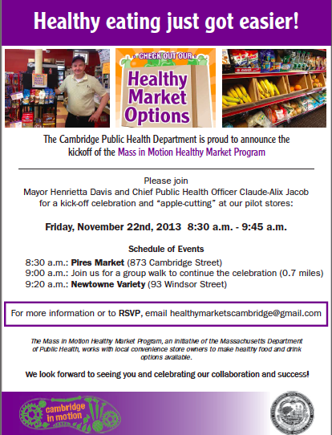

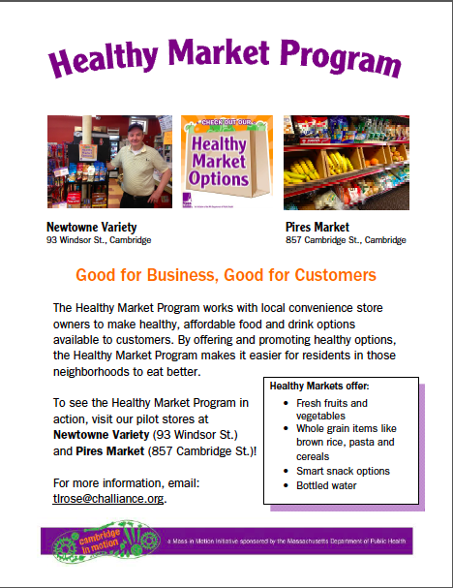
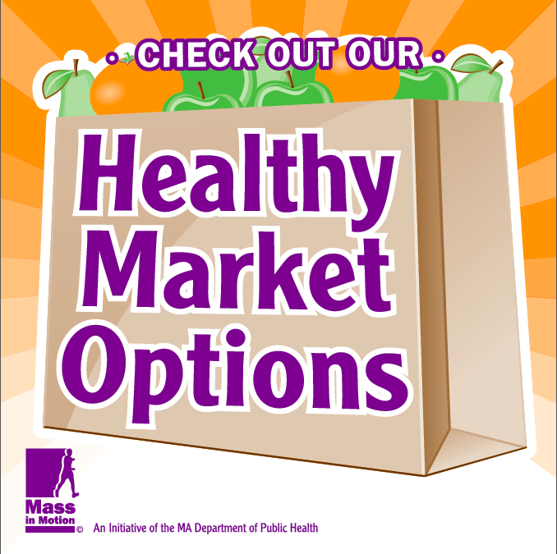
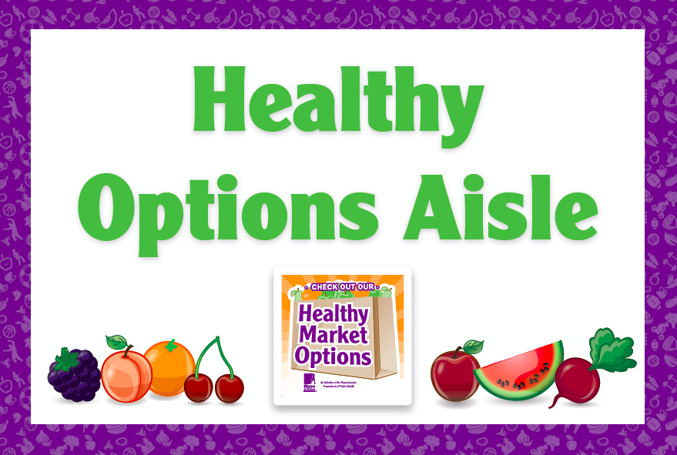
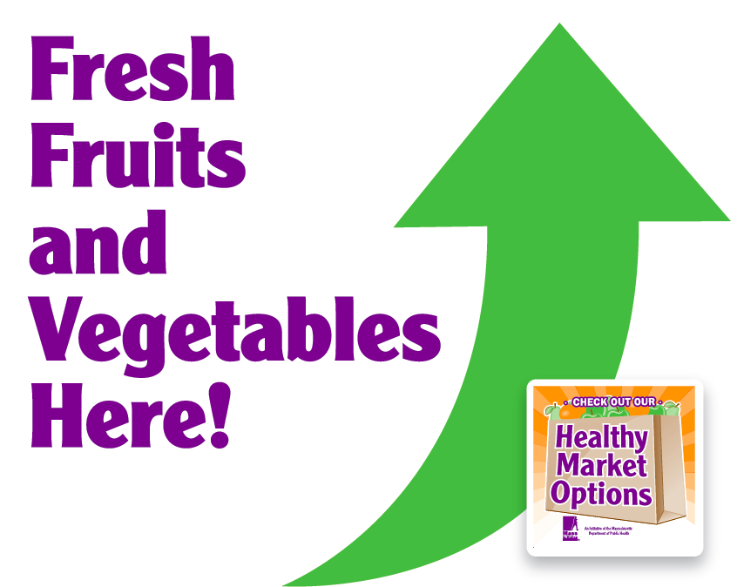
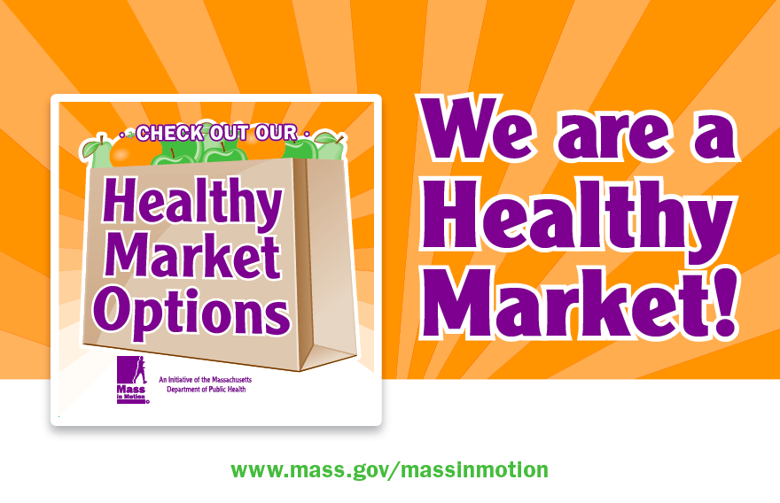

Plymouth Press Release

The Market at The Pinehills has been named the first “Healthy Market” in Plymouth and the South Shore region by the Massachusetts Department of Public Health, Jordan Hospital, and Healthy Plymouth. And we’re celebrating with a launch event on Monday, August 12th at 11 AM.

All are welcome, and attendees can taste delicious “healthy” food created by Chef Dane and tour The Market and see and taste the various components of the Healthy Market program. A reusable shopping “goody bag” with a recipe book, nutritional guides, and samples will be available for the first 100 attendees so mark your calendars!

The Healthy Market program will launch on the 12th at 11 AM with comments from:

Peter Holden – President, Jordan Hospital
Cheryl Bartlett – Commissioner of Public Health, State of Massachusetts
Matt Murastore – Chair, Plymouth Board of Selectmen
Sue Blackington-Harris – General Manager, The Market at The Pinehills

The Market at The Pinehills meets all of the criteria we outlined for a “Healthy Market,” said Marcia Richards, Healthy Plymouth Nutrition Facilitator and Jordan Hospital Dietician. They have a tremendous variety of fresh, local produce; offer healthy food options throughout the store including many gluten-free, low sodium, and low-fat products; comply with all tobacco and alcohol regulations and so much more. The Market at The Pinehills and the Healthy Market Program are a perfect fit.

When shoppers come to The Market at The Pinehills, they will find special “Healthy Market” signage placed adjacent to products throughout the store helping them find healthy, nutritional options. In addition, Jordan Hospital is working with Chef Dane to have nutritional information available and on display for a weekly rotation of selected prepared foods, outlining calories, fat content, protein, and sodium content per serving.
Memorandum of Agreement

Store: The Market

Address: 6 Purchase Street
Plymouth, MA. 02360

Phone Number: 508-209-0000

This Healthy Market Agreement outlines the activities that will be provided by Healthy Plymouth to help implement the Healthy Market Program at The Market. The services will be provided to The Market for implementing specific criteria. The agreement will be effective for the period of one year ending August 12, 2014.

The Market is committed to the following:

- Stock healthy foods including high quality fresh fruits and vegetables, whole grain products, low-fat and fat-free dairy products, 100% juices, heart healthy entrees and protein foods, and healthy snack options.
- Label and promote healthy options.
- Adhere to high business standards by keeping prices of healthy foods as affordable as possible and by participating in the SNAP program.
- Comply with all laws regarding the sale of alcohol to minors. The Market does not sell tobacco products.

Healthy Plymouth will assist The Market by:

- Offering assistance and resources in a variety of ways to help ensure the store meets the Healthy Market Program goals.
- Monitoring the store’s progress, including evaluations and informal check-ins with the store’s General Manager.
- Promote The Market as Plymouth’s and the South Shore’s first Healthy Market.
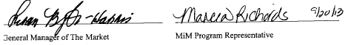

SOURCES

The Boston Healthy on the Block project:
http://www.bphc.org/whatwedo/healthy-eating-active-living/healthy-on-the-block/Documents/Healthy_On_The_Block_Toolkit.pdf

The Delridge Healthy Market project:
http://www.healthycornerstores.org/wp-content/uploads/resources/Delridge_HCS_Toolkit.pdf

Healthy Food Here Produce Guide
https://catalyst.uw.edu/workspace/file/download/39849f216242049a3dc80ff6fc512cc6238b5508328034c2240ee79198ebfa2f

Market Makeovers
www.marketmakeovers.org

The Minneapolis Healthy Corner Store Program:
http://www.healthycornerstores.org/evaluation-tools-from-the-minneapolis-healthy-corner-store-program

New York Healthy Bodega project:
http://www.nyc.gov/html/doh/downloads/pdf/cdp/healthy-bodegas-rpt2010.pdf

APPEALING TO CORNER STORES – EVIDENCE FROM EXISTING PROGRAMS

Minneapolis Healthy Corner Store Program (link)
- Program elements: Increased visibility of fresh produce sections, displayed and maintained healthy corner store marketing materials and signage, provided one-on-one trainings or group trainings on produce merchandising and handling, implemented and maintained improvements to produce selections
- Results in intervention stores: More consistent upward trend in sales and transactions from pre-store enhancement to post-store enhancement, 155% increase in produce sales and a 146% increase in produce transactions (compared to a 22% decrease/11% decrease in control stores)

Shop Healthy NYC
- Program elements:
  - Product
    - Stock healthier deli options
    - Stock healthier canned goods
    - Stock two healthy snacks
  - Placement
    - Display water and low calorie refrigerated snacks at eye level
    - Display produce at the front of the store or at checkout
  - Promotion
    - Post Shop Healthy marketing materials
    - Feature entry door free of advertising
- Of those who saw any Shop Healthy materials (65% of respondents):
  - 64% said that the material made them consider purchasing the healthier option advertised
  - 49% actually purchased an advertised product
  - 84% said the material made them think about eating healthier
  - 75% reported that the signs made them feel positively about the store

The Food Trust – Placement and Promotion Strategies
- Strategies:
  - Multiple facings
  - Prime placement
  - Signage
  - Secondary placement
- Influential for milk
  - Skim milk sales were relatively stable in the intervention stores, whereas they declined in control stores
  - Sales of 1% milk improved significantly in intervention stores as compared to control stores

Systematic Review of Grocery Store/Supermarket Interventions
- Interventions that had sufficient levels of evidence:
  - Point of purchase AND promotion and advertising
  - Point of purchase AND increased availability of healthy foods AND promotion and advertising
  - Point of purchase AND pricing AND increased availability of healthy foods AND promotion and advertising
- Interventions combining demand- and supply-side strategies have sufficient evidence to influence the customers and management toward more healthful purchases

Powell, L., Slater, S., Mirtcheva, D., Bao, Y., and Chaloupka, F. “Food Store Availability and Neighborhood Characteristics in the United States.” American Journal of Preventive Medicine, 44 (2007): 189–195.
Bodor, J. N., Rose, D., Farley, T. A., Swalm, C., and Scott, S. K. “Neighborhood Fruit and Vegetable Availability and Consumption: The Role of Small Food Stores in an Urban Environment.” Public Health Nutrition, 11 (2008): 413-420.
Your program logo will be added if space permits; this will depend on the orientation of the logo. Some vertically-oriented logos may not fit in the space, but your community’s program name will always be included. To ensure use of high resolution files appropriate for printing, please do not attempt to design on your own.

