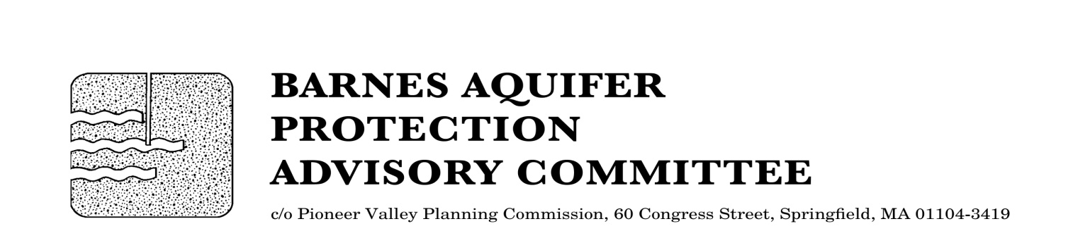

MEETING NOTICE

BARNES AQUIFER PROTECTION ADVISORY COMMITTEE

DATE: Tuesday, November 1, 2016

TIME: 3:30 p.m.

PLACE: Easthampton City Hall (downstairs)
50 Payson Avenue, Easthampton, MA

Agenda
- Adoption of meeting notes
- October 4, 2016

- Citizen speak

- Developments of regional impact
- Airport Aviation Museum, Westfield
- Roots Athletic Center, Westfield - location for monitoring well
- Westfield wells update

- Finalize Annual report for FY2016 and workplan for FY2017

- Updates
- Massachusetts Environmental Trust grant request
- Cook Road land protection
- Request to review Westfield Water Resources Protection District ordinance
- Salt Study - follow up

- Other business

- Next meeting date

City/Town Clerks: Please post this notice per Massachusetts General Laws,
Chapter 39, Section 23, A-C

