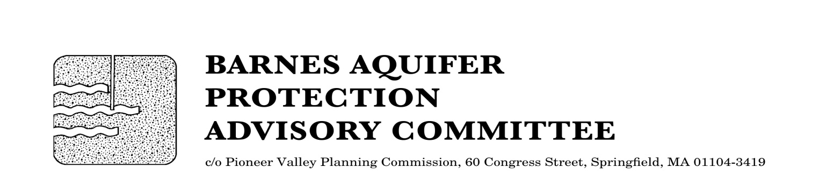

MEETING NOTICE

BARNES AQUIFER PROTECTION ADVISORY COMMITTEE

DATE: Tuesday, June 7, 2016

TIME: 3:30 p.m.

PLACE: Easthampton City Hall (downstairs)
50 Payson Avenue, Easthampton, MA

Agenda

- Recognition of Charles "Woody" Darling (and appointment of chair for FY2017)

- Citizen speak

- Adoption of meeting notes
- May 3, 2016

- Developments of regional impact
- Closing of Westfield wells 7 and 8

- Updates
- Cook Road land protection

- Work plan for FY2017

- Other business

City/Town Clerks: Please post this notice per Massachusetts General Laws,
Chapter 39, Section 23, A-C

